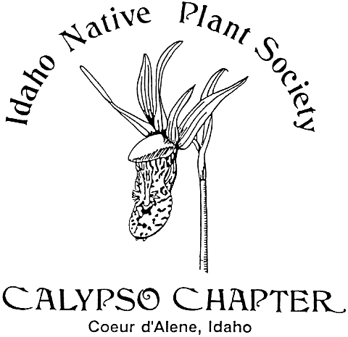 Calypso Companion
April 2017 Vol. 25

Newsletter yearly subscription: Free to Members
Editor:
President: Derek Antonelli- antonelli8@frontier.com
Vice President: Vacant
Secretary; Karen Williams-williamskaren322@gmail.com
Treasurer: Janet Benoit- jebenoit@sisna.com
Mail: P.O. Box 331, Careywood, ID 83809
Phone: (208) 683-2407

The Calypso Chapter of the Idaho Native Plant Society meets on the first Wednesday of March,
April, May and October. The Chapter schedules field trips during the spring, summer, and fall.
The Calypso Chapter of the INPS was founded in 1991. We continue our efforts in promoting
interest in native plants and native plant communities, collecting and sharing information on all
phases of botany concerning this flora. Membership is open to all interested in the native plant community.
________________________________________________________________________
Next Meeting
The next meeting is Wednesday April 5, 2017 at 7:00 p.m. at the Idaho Fish and Game Building at 2885 W Kathleen, Coeur d’Alene, directly across from US Forest Service Nursery on the west end of Kathleen near Atlas Road.
DUES ARE DUE for 2017.
Agenda
Business meeting
Minutes from last meeting
Treasurer’s report
Old business
New business

Program: Preston Hill will present the proposal to expand The Upper Falls
Community Forest near Post Falls and Q'emiln (Ka-mee-lin) Park.

Upcoming Calypso Chapter Events:
TGWO “Thank God Winter’s Over” hike, March 25, 10:00 am, meet in Coeur d’Alene at Tubbs Hill east entrance parking lot, S. 10th St.
Wed. April 5-Chapter Meeting, 7 PM Urban Forester Preston Hill “Upper Falls Community Forest” expansion proposal near Q’emiln Park, Post Falls.
Sat. April 8-Antoine Peak plant hike and survey. Leader Dave Nobel (bring a camera and GPS). 10:00 am, meet at Walgreens at Appleway and US 95 to carpool.
Sat. April 22- Earth Day Fair 12:00-4:00 CDA Library. Calypso Chapter will feature the native milkweeds that are important to our pollinators the Monarch Butterflies. Free seeds!
There will be an additional April plant hike date and time TBA.
March 1, 2017 Meeting Notes of the Idaho Native Plant society
President Derek opened the 7 PM meeting and the February meeting notes were approved by the club. Up next was a review of the Calypso companion newsletter’s featured plant Monotropa uniflora or “ghost plant”. Not a fungus as some might think, the saprophytic plant gets it’s nutrients via a complex association with tree roots and the Russala genus of fungi.
Michael walker, professional architect and volunteer, presented possible design plans for the new 16 acre Veteran’s Park near Fernan Lake. This proposal has been spearheaded by the CDA Natural Open Space Committee and supported by others including members of the Urban Forestry Committee. Besides improving access to the site, the master plan may include a picnic shelter, vault toilet, playground, amphitheater to host education nature programs, a hiking trail and other developments which would be positive additions to the neighborhood. The group is interested in being respectful of the native landscape and is seeking advice on adding appropriate native trees, shrubbery and wildflowers. While there is an existing homestead well, water sources are limited and are an important consideration for plantings placements such as near existing wetland areas. Information sources include the U of Idaho, Audubon Society, and the Idaho Forest Owners, and Society of Foresters as well as our group. Other projects the Natural Open Space Committee has been involved with include, Tubb’s Hill, the forested portions of Cherry Hill, Winton Park, Fernan Hill Park and, Canfield Mt. Many have volunteered much time for this project to proceed. We will follow this project and hope to offer additional assistance in any way we are able.
Janet gave the Treasurer’s Report with a club balance of $1, 046.23. Dues are due for 2017. The Teacher’s Credit Union would be a potential for a free checking account. Laura mentioned the upcoming Annual Meeting of the WA Native Plant Society would be at Cheney, WA. May 19- 21, 2017.

Featured Plant for April, 2017-Redstem ceanothus, Ceanothus sanguineus, Family-Rhamnaceae-Oregon teatree.
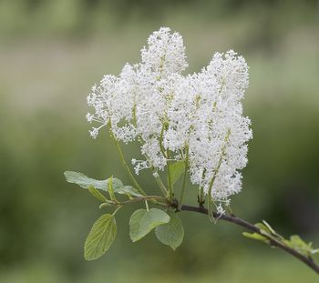

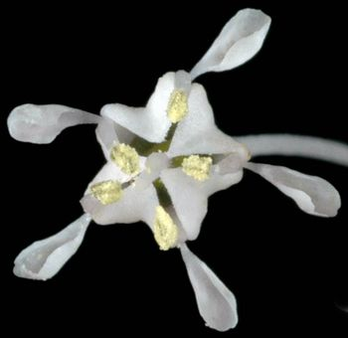
Blooms: May-July
Habit: shrub
Duration: perennial
Origin: Native
Conservation Status: Abundant; of no concern.
Distribution: Widely distributed on both sides of the Cascades in Washington; British Columbia to California, east to Idaho.
Habitat: Moist to dry open woods, low to moderate elevations.
General: Glabrous, deciduous shrubs, the stems erect, 1-3 m. tall, somewhat purplish.
Leaves: Leaves alternate, the blades ovate to ovate-elliptic, 3-10 cm. long, thin, with fine, rounded serrations and glands; stipules 3-6 mm. long, quickly deciduous.
Flowers: Flowers in dense panicles on short lateral branches of the previous year’s growth; calyx 5-lobed; petals 5, long-clawed, hooded, white; stamens 5, opposite the petals, separated from the pistil by a flat, lobed disk, which also embeds the ovary; style 1, stigmas 3.
Fruits: Capsules about 4 mm. long, deeply 3-lobed, not crested.
Source: Washington Burke Museum Herbarium

Roland Craft- March 26, 1929-March 14, 1917
Our good friend and knowledgeable plant enthusiast, Roland Craft passed away recently at the age of 87. Roland with his Degree in Forestry was a valuable asset to have on our Native Plant field trips. He was always eager and enthusiastic to share this knowledge. We learned from him the proper terms to describe trees as “conifers and not evergreens” as well as identifying the many tree species of our area and their characteristics. He loved to plant trees everywhere the family lived. A true outdoorsman, Roland enjoyed camping, hiking and especially fishing and floating the Clearwater River with friends and family. Please visit Roland's memorial and sign his online guestbook at www.yatesfuneralhomes.com - See more at: http://www.legacy.com/obituaries/spokesman/obituary.aspx?pid=184577769#sthash.7ondc5ig.dpuf

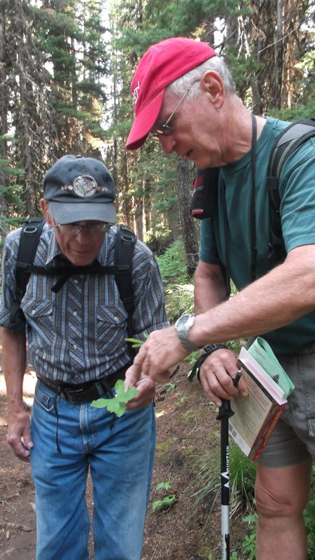

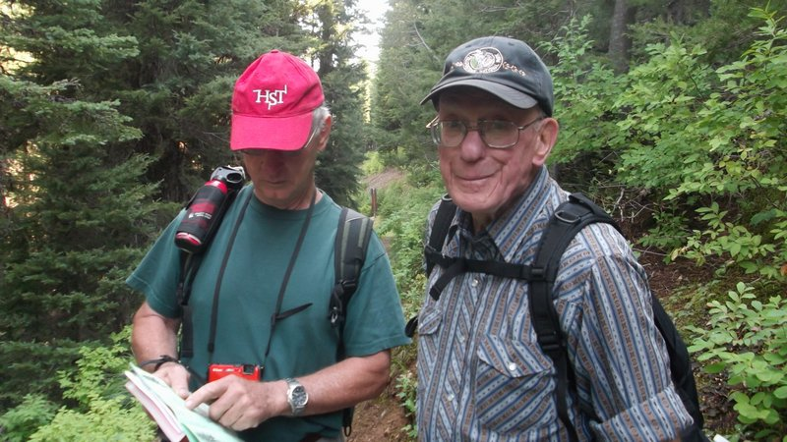
Roland Craft and John Lee on Revette Lake Field Trip
(Photos by Susan Lee)

