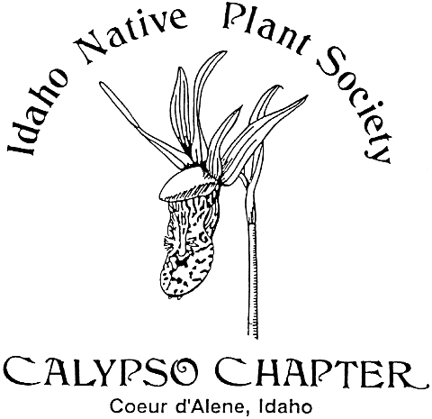 Calypso Companion
March 2017 Vol. 24.9

Newsletter yearly subscription: Free to Members
Editor:
President: Derek Antonelli- antonelli8@frontier.com
Vice President: Vacant
Secretary; Karen Williams-williamskaren322@gmail.com
Treasurer: Janet Benoit- jebenoit@sisna.com
Mail: P.O. Box 331, Careywood, ID 83809
Phone: (208) 683-2407

The Calypso Chapter of the Idaho Native Plant Society meets on the first Wednesday of March,
April, May and October. The Chapter schedules field trips during the spring, summer, and fall.
The Calypso Chapter of the INPS was founded in 1991. We continue our efforts in promoting
interest in native plants and native plant communities, collecting and sharing information on all
phases of botany concerning this flora. Membership is open to all interested in the native plant community.
________________________________________________________________________
Next Meeting
The next meeting is Wednesday March 1, 2017 at 7:00 p.m. at the Idaho Fish and Game Building at 2885 W Kathleen, Coeur d’Alene, directly across from US Forest Service Nursery on the west end of Kathleen near Atlas Road.
DUES ARE DUE for 2017.
Agenda
Business meeting
Minutes from last meeting
Treasurer’s report
Old business
New business

Meeting Notes of October 5, 2016

Janet’s treasure’s report-Balance of $1305 including savings. Minutes of last meeting were approved. Blackwell Island Native Garden Project update: Signage will be placed at the site in spring of 2017. Annual Meeting update: CDA River (Bumblebee Campground) is still under consideration for our 2018 site which Calypso will be hosting. There are several available hikes for field trips nearby. The featured plant a Mt. Holly Fern was reviewed.
Program: Bob Wilson of Cedar Mt. Perennials, “Propagation of Native Plants”. Bob is active in the Sandpoint Native Plant Society, a member of the Calypso chapter, and is also an extension agent for the Sandpoint area. Main points of the talk were as follows:
A seed is encapsulated genetic material which includes food storage and a seed coat. What does a seed need to grow? Water, adequate temperature and porosity for air. A shortage of current data makes record keeping important. Factors that affect growth-Seed viability, pollination stress age, seed coat, dormancy, light, natural variability. Where to find information? Http//npn.mgr.net/propagation is an agency sponsored website. Books, “Growing Native Plants in the Rocky MT’s”. Native Plant Journal has some information also. Seed not sprouting is not a result of the seed coat but usually a chemical germination inhibitor. Activation is caused by moisture and cold (cold stratification). Freezing is not always necessary. Some do best outside. All ingredients except sand need to be sterilized. Scarification (w/sandpaper), hot water and some acids (which mimic stomach digestion of animals) are ways to break the seed coat to allow water in. Some seeds don’t need light (light neutral). Available seed sources are Western Native Seed and Plants of the Southwest. Collecting seeds. Seeds need to be dry and mature. Clean and dry the seeds for storage and keep cool. Use ethical standards when collecting (no more than 10% of the population) Growing plants from cuttings. Woody or herbaceous cuttings may be used. Don’t use flowering branches. Keep warm and moist. Plant in perlite or sand/perlite media. Takes less time than seeds. Cuttings will keep the plant characteristics. Heat pads may be used for both using seeds and plant cutting methods. The club is planning to visit the Cedar Mt Gardens for a spring field trip and tour.
Karen Williams, Secretary

Photos from Oct 5, Meeting

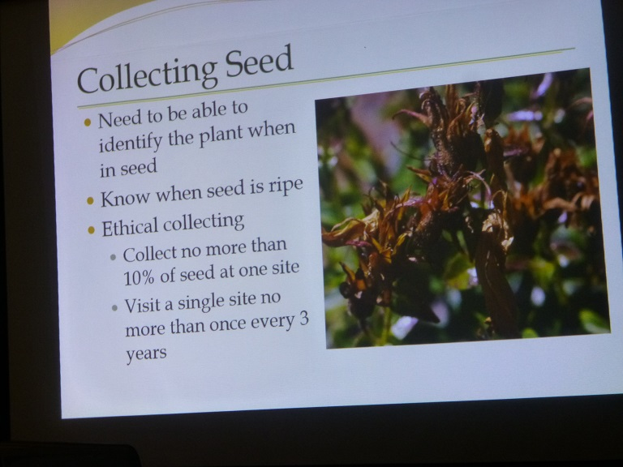
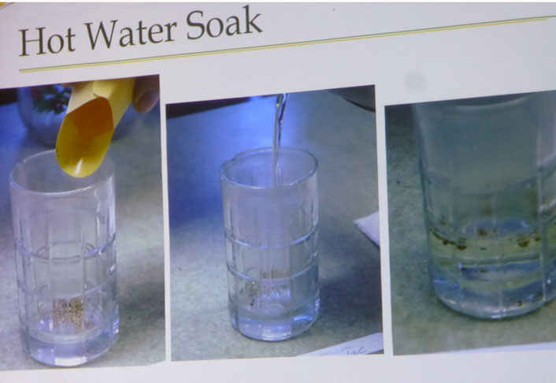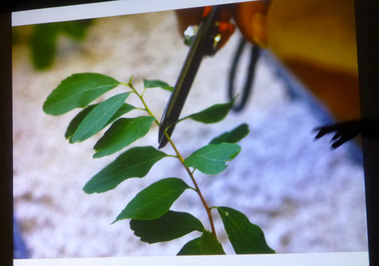

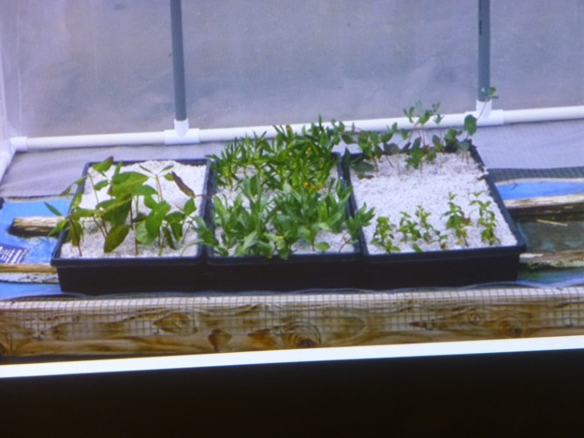

Featured Plant for March, 2017- Indian pipe or Ghost plant: Monotropa uniflora Family: Monotropaceae.
General: Saprophytic perennial, lacking chlorophyll, 5-25 cm tall, with waxy-white flower clusters which turn black with age. The common name “Indian pipe” refers to the pipe-like flowering stalks.
Leaves: Alternate, linear to egg-shaped, white and scale-like.
Fruits: Erect brown capsules, splitting open into 5 segments. Ecology: Moist shaded woods; foothills to subalpine.
Flowers: Waxy-white and solitary, nodding when young, erect when mature.
Notes: Indian pipe roots and those of nearby trees such as pine, join in a complex association with a fungi, the genus Russula. Nutrients are thus transferred, enabling the Indian pipe plant to survive without photosynthesis.

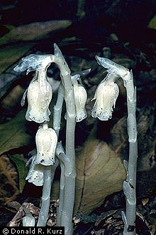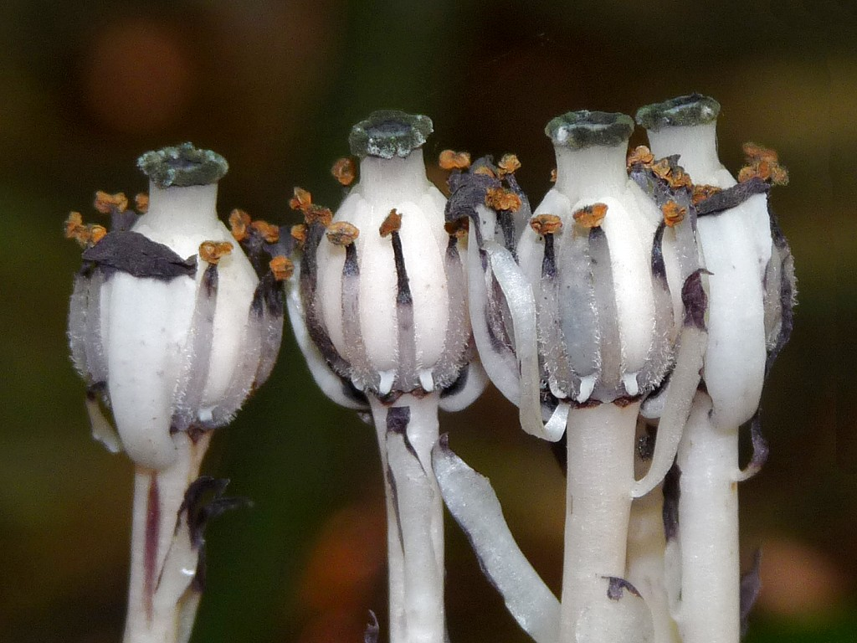
Submitted by Karen Williams with special thanks to Kelly Chadwick for his article in Outthere Monthly magazine.

