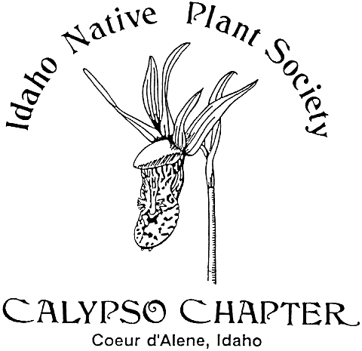 Calypso Companion
May 2017 Vol. 25.1

Newsletter yearly subscription: Free to Members
Editor:
President: Derek Antonelli- antonelli8@frontier.com
Vice President: Vacant
Secretary; Karen Williams-williamskaren322@gmail.com
Treasurer: Janet Benoit- jebenoit@sisna.com
Mail: P.O. Box 331, Careywood, ID 83809
Phone: (208) 683-2407

The Calypso Chapter of the Idaho Native Plant Society meets on the first Wednesday of March,
April, May and October. The Chapter schedules field trips during the spring, summer, and fall.
The Calypso Chapter of the INPS was founded in 1991. We continue our efforts in promoting
interest in native plants and native plant communities, collecting and sharing information on all
phases of botany concerning this flora. Membership is open to all interested in the native plant community.
________________________________________________________________________
Next Meeting
The next meeting is Wednesday May 3, 2017 at 7:00 p.m. at the Idaho Fish and Game Building at 2885 W Kathleen, Coeur d’Alene, directly across from US Forest Service Nursery on the west end of Kathleen Avenue near Atlas Road.
DUES ARE DUE for 2017.
Agenda
Business meeting
Minutes from last meeting
Treasurer’s report
Old business
New business

Upcoming Calypso Chapter Events: Wed. May 3, Calypso Chapter Meeting 7PM, Idaho Fish and Game Office, 2885 W Kathleen Ave, Coeur d’Alene. Presentation: “Hager Lake: A Rare Idaho Peatland”
Sun. May 7, Q’emiln Park hike with Preston Hill. Meet at trailhead parking lot at 10AM. In Post Falls take Spokane Ave south across river. Take first right to the trail at end of the road.
Sat. May 13, 10AM Antoine Peak Conservation Area Hike/Survey, meet at Walgreens at Appleway and US 95 to carpool.
Friday May 19-Cedar Mountain Perennials Field Trip, meet 10AM at Hayden Walmart parking lot in the northeast corner.
Meeting Notes of April 5, 2017. Our guest speaker was Urban Forester for the City of Post Falls, Preston Hill. The city is has been acquiring land parcels near the 58 acre Q’emiln Park area with the goal of protecting the natural landscape and increasing public access. Included are 2.25 miles of Spokane River shoreline. Another important component of the project will be the opportunity to connect other parks and properties such as Corbin Park, the Centennial trail and Avista Islands. It was noted that a ‘Community Forest has certain standards and requirements that must be met and differs from an “Urban forest” which includes all trees and foliage in the city. Funding for acquiring the current acquisition is with a grant which has stipulations which include public educational programs, environmental benefits to the community and public access. Another important component of the project will be the reuse of wastewater from the city of Post Falls by land application. It is a probability this will cause certain changes over time to the forest composition. Mr. Hill thanked the group for their written support of the project. Others supporters include Idaho State Senators, the State Parks Association, local schools and North Idaho College among many others. The final project will include over 500 acres of natural landscape. Calypso Chapter is helping with native plant identification with current resource data from many plant surveys in the area and is planning at least one future field trip to the site.

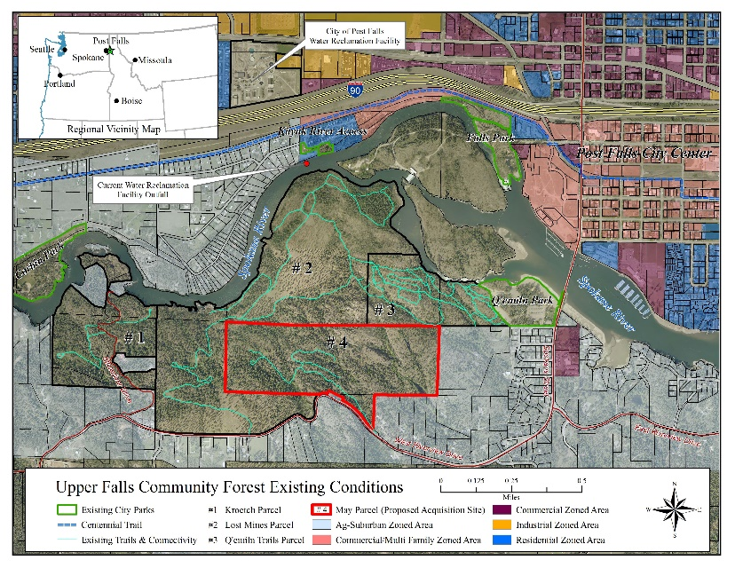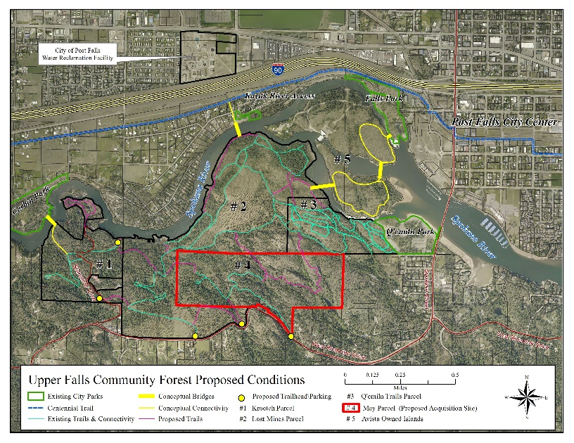
Existing Conditions Proposed Conditions
Featured Plant For May 2017
Revisiting the Lichens-(They’re addictive) - an organism made up of a fungus and algae. Pilophorus acicularis, Devils Matchstick, a Nail or club lichen, found on noncalcareous rock, rarely wood. Usually in partial shade in openings in low to mid-elevation moist forests, often near creeks or waterfalls; also frequent on rocky road cuts. Reproduction: Tiny black, ball-like apothecia at club tips. Distribution: coastal disjunct. This lichen was recently reviewed by the North Idaho Rare Plant Working Group. Roadwork is the most serious threat for this lichen. The Group recommended an S2 Idaho Rank.
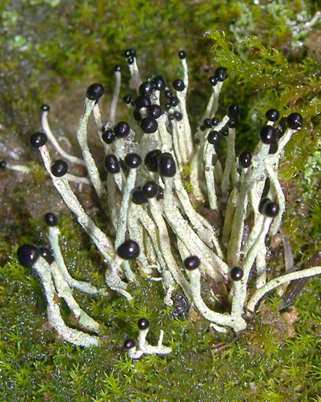
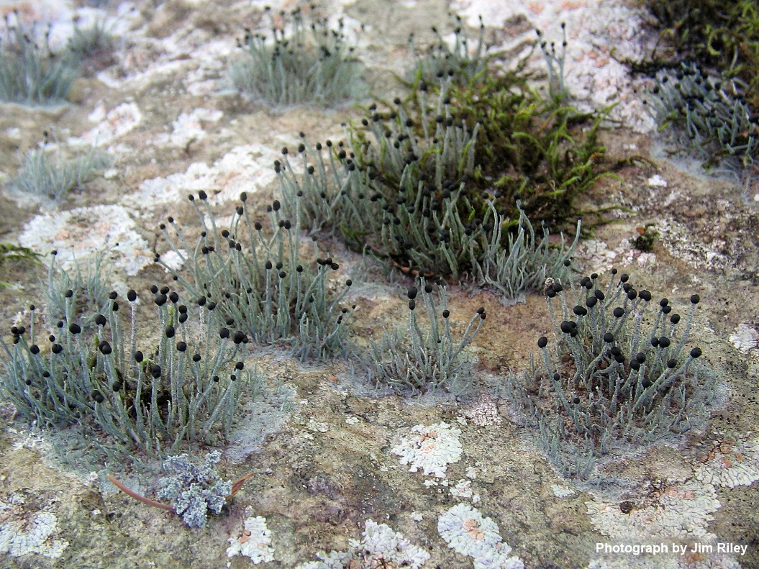
Pilophorus acicularis

Earth Day 2017 The Event was organized by the Kootenai Environmental Alliance. Our calypso Chapter booth featured “Save the Monarch” butterfly which is declining in North America due to many threats such as lost habitat and climate change. Free milkweed seeds, the plant Monarchs need to survive were also given away. Derek supplied a scope for viewing plant, lichen and moss species and Dave Noble brought live moss and lichen specimens. Thanks to Jackie, Ellie, Pat, Dave, Derek and Karen for volunteering at our booth.
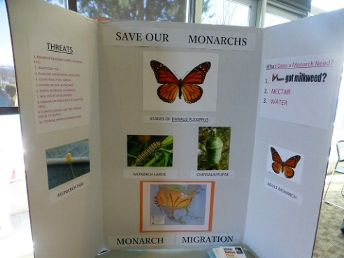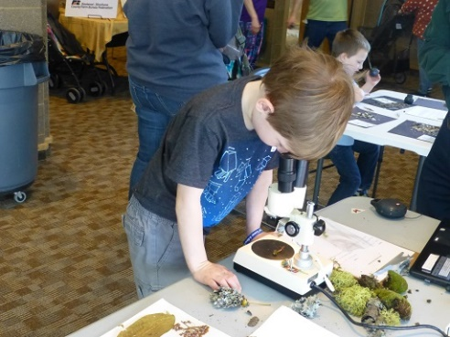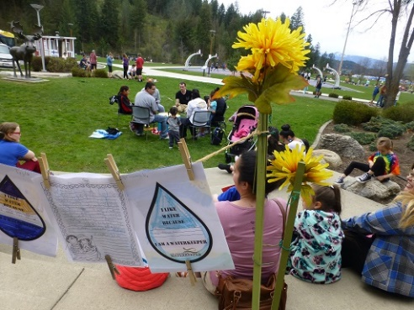
More Upcoming: Rare Plant Surveys, spring/summer, Derek Antonelli will be leading rare plant surveys throughout the season around the area, contact Derek to get on the email list if you would like to help out/tag along.
June 17 (tentative), CDA River area near Bumble Bee CG, Coal Creek, Fern Falls.
July 8, Antoine Peak Plant Survey. Leader Dave Nobel (bring a camera).
July-14-17, INPS Annual Meeting in Challis, ID.
August, possible field trip to Hagar Lake, Huff Lake.
Chapter Meeting, October 4, 7:00 pm, Idaho Fish and Game Office, 2885 W Kathleen Ave, Coeur d’Alene. Tentative presentation: Plants of the Ponderosa Pine/Douglas fir forest habitat types

