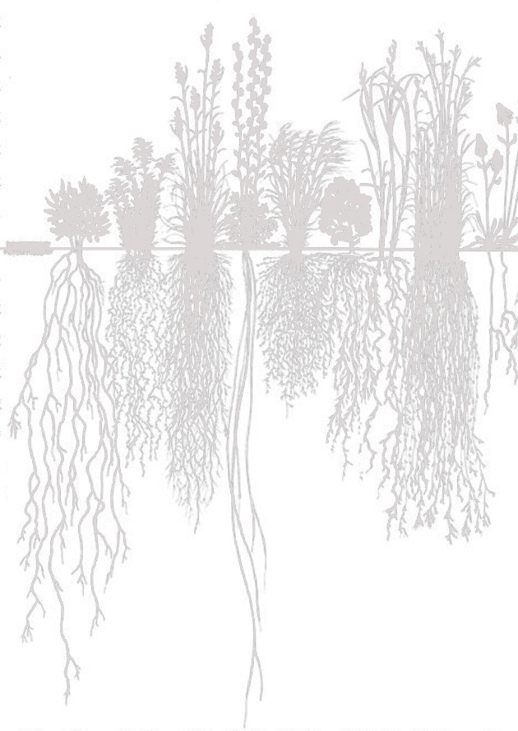
Sage Steppe
GRASS-SOIL Field WORKSHOP
Sponsored by the Idaho Native Plant Society
No fee

Roger Rosentreter PhD
Botanist and plant ecologist, Adjunct professor in Biology Department at Boise State University, will lead a field workshop looking at native grasses in sage steppe.

22-24 May 2020

LOCATION
15 miles south of Jackpot, on US 93, Elko County, Nevada. Turn west off US 93 at the Contact sign on the highway, go ½ mile up the dirt road, turn left (south) and go ½ mile to the red-roofed house, which you can see. 41.770886, -114.764084

SCHEDULE
Arrival Friday afternoon or evening, no events scheduled
Saturday - Workshop beginning 9am, through afternoon
Sunday - Field trip to Blue Jay Spring, riparian area 2 miles south 9-3 PM

ACCOMMODATION AND MEALS
Camping is possible on BLM land next to the workshop location, with a toilet and kitchen available. Hotels and restaurants are in the casino town of Jackpot, 15 miles north on US Highway 93. The main hotels In Jackpot are Cactus Pete’s, Four Jacks Hotel and Casino, Barton’s Club 93 and Horshu Hotel.

Please RSVP to Karen at kklitz101@gmail.com

