*֎Botrychium hesperium (Maxon & R. T. Clausen) W. H. Wagner & Lellinger
– Western moonwort
Ophioglossaceae – adder’s tongue family
Account written by Harpo Faust and Derek Antonelli, 12/17/2020 ֎*
Recommended S1 by North Idaho Rare Plant Working Group on 1/12/2020

Current Conservation Status:

*NatureServe³: G4, Idaho SNR

British Columbia S4, Montana S3, Oregon S1, Washington S2, Wyoming S1

2009 INPS rank²: Not listed

BLM: Not listed
FS Reg 1: Sensitive in Montana but not listed for Idaho
FS Reg 4: Not listed
FS Reg 6: Sensitive

FWS: Not listed

Taxonomy: Amer. Fern J. 71: 92. 1981.

Synonyms: Botrychium matricariifolium ssp. hesperium Maxon & R. T. Clausen

Other Subspecies/Varieties, if applicable: None

Type Locality:

*Taxonomic key(s)⁷: Flora of the Pacific Northwest, 2nd Ed., Flora of North America, Volume 2

Species Description (OPTIONAL):

Trophophore stalk 0–3(–10) mm, to 1/4 length of trophophore rachis; blade ± gray-green, dull, oblong-linear to deltate, 1–2-pinnate, to 6 × 5 cm, firm. Pinnae to 6 pairs, ascending, usually approximate or overlapping except in shade forms, distance between 1st and 2d pinnae not or slightly more than between 2d and 3d pairs, basal pinna pair commonly much larger and more divided than adjacent pair, lobed to tip, basal pair oblong to oblong-lanceolate with lobed margins, remainder broadly spatulate with entire margins or 1 or more shallow lobes, apex rounded, venation pinnate. Sporophores 1–3 pinnate, 2–3 times length of trophophore. 2n =180. (from FNA)

Biology: Life span (perennial), growth form (fern); phenology: leaves appearing in midspring, dying in early fall.

Similar species: Many other Botrychium species

Habitat: Elevation 200 – 2800 m; grassy mountain slopes, snow fields, road ditches with willows, and sand dunes

*֎Environmental Specificity¹⁰:

Cultural and commercial values:

Landownership: Panhandle National Forest

Distribution:

Global Range: North America endemic (map from FNA)
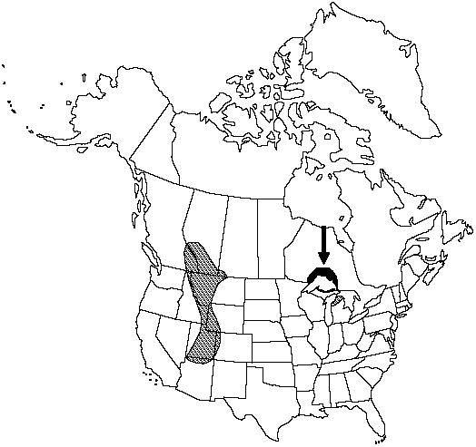

*Range Extent Descriptor⁶: Peripheral

֎Rank Calculator Idaho Range Extent: Known from a single population (less than 1 km²)

֎Area of Occupancy: One. Calculator category (A).

*Idaho Counties⁹: Boundary

Idaho Specimens:
Record source (Herbarium, IFWIS, person) | Date observed/ collected | Observer | County | Location | Abundance, threats, habitat condition
Faust 3552 | 7/21/2020 | Harpo Faust and Whitney Griswold | Boundary | Bog Creek Road | About 100 individuals, serious threat from road work

Literature Records:

Databases/Herbaria consulted: See Information Sources section below

Research Notes: This collection is first for Idaho

Abundance:

*֎Number of Occurrences⁸: One (A)

֎Population Size: About 100 individual stems (B)

֎Number of Occurrences with Good Viability: Occurrence was not rated for viability so number with good viability is between zero and one (AB).

Conservation concerns:

֎Threats (include scope, severity and timing, if known): The entire population is in the roadbed of the Bog Creek Road. That road will be upgraded in a joint USFS/Homeland Security project to improve the US Border Patrol’s access to the US/Canadian border. The road work activity has the potential to wipe out the entire population. If the population survives the construction activity, ongoing road use may impact the population by crushing individuals.

*֎Overall Threat Rank¹¹: Very high (A).

֎Intrinsic Vulnerability:

Population trend:

֎Short:

֎Long:
Proposed rank information:

*Date Ranked⁵: NIRPWG recommended rank on 1/12/2021

*Proposed Rank: S1

*Proposed INPS Status²: Rare

*Comments¹²:
*Recommended actions¹³:

INPS send letter requesting protection for population during Bog Creek road construction activities.

Protect population during construction for upgrade of Bog Creek Road.

US Forest Service Region 1 should add species as sensitive species (or equivalent) and manage appropriately.

Information Sources:

Consortium of Pacific Northwest Herbaria. (http://www.pnwherbaria.org, December 2020).

Biota of North America Program, North American Vascular Flora (http://bonap.net/NAPA/Genus/Traditional/County, December 2020)

Flora of North America, Volume 2.

Hitchcock, C.L. and A. Cronquist. 2018. Flora of the Pacific Northwest: An Illustrated Manual, 2nd Edition. Edited by D.E. Giblin, B.S. Legler, P.F. Zika, and R.G. Olmstead. University of Washington Press, Seattle, WA. 936pp.

NatureServe Explorer. (http://explorer.natureserve.org, December 20120)

USDA, NRCS. 2019. The PLANTS Database (http://plants.usda.gov, December 2020).

USDHS and USDA. February 2019. Final Environmental Impact Statement – Bog Creek Road Project. 515pp.

