Calliergonella cuspidata (Hedwig) Loeske – calliergonella moss
Family: Amblystegiaceae
Account written by Derek Antonelli, 12/26/2020
Rank of S1S2 Recommended by
North Idaho Rare Plant Working Group on 1/18/2022

Current Conservation Status:

*NatureServe³: G5, NNR, Idaho SNR Other states: British Columbia S4S5, Washington SNR,

Oregon SNR, Montana SNR, Wyoming SNR

2009 INPS rank²: Not listed

BLM:
FS Reg 1: Not listed
FS Reg 4: Not listed
FS Reg 6: Not listed

FWS: Not listed

Taxonomy: Published in Hedwigia 50: 248. 1911.

Synonyms: Hypnum cuspidatum, Calliergon cuspidatum

Other Subspecies/Varieties, if applicable:

Type Locality:

*Taxonomic key(s)⁷: Common Mosses of Western Oregon and Washington; Flora of North America, Vol 28

Species Description (OPTIONAL): Plants to 7 cm, in loose tufts or mats. Stems erect, semierect, or decumbent, terete-foliate, pinnate when erect, irregularly branched when decumbent, flattened in cross section, usually turgid at stem and branch apices; outer cortical cells in 3 or 4 layers, inner cortical cells large, walls thin; pseudoparaphyllia foliose; axillary hair basal cell 1, short, brown. Stem leaves ovate, short, broad; apex acute and weakly cuspidate to rounded; costa double, short, usually inconspicuous, or ecostate; supra-alar cells often ± quadrate, walls thicker than those of alar cells; inner basal laminal cells short-elongate, walls thick, pitted; apical cells short, weakly sinuate. Branch leaves lanceolate, longer; apex usually cuspidate; ecostate or costa double, short; alar region ± auriculate. Perigonia axillary, budlike, apex flaring. Perichaetia axillary, inner leaves long-lanceolate, plicate, margins weakly serrate basally, apex flaring at archegonial maturity, ecostate. Seta long, ± erect. Capsule with exothecial cells collenchymatous; annulus differentiated, 2–4-seriate; operculum conic-apiculate; exostome teeth with external surface striolate basally, papillose distally; endostome basal membrane high, segments keeled, perforate. Spores finely punctate. From FNA.

Biology: Life span (perennial), growth form (moss)

Similar species:

Habitat: Elevation from low to high; Calcareous wetlands, moderately rich fens, among sedges, lake margins, roadside ditches, weed in lawns

*֎Environmental Specificity¹⁰:

Cultural and commercial values:

Landownership: Federal (agency/district), tribal (nation), state, private, other

Distribution:

Global Range: Worldwide
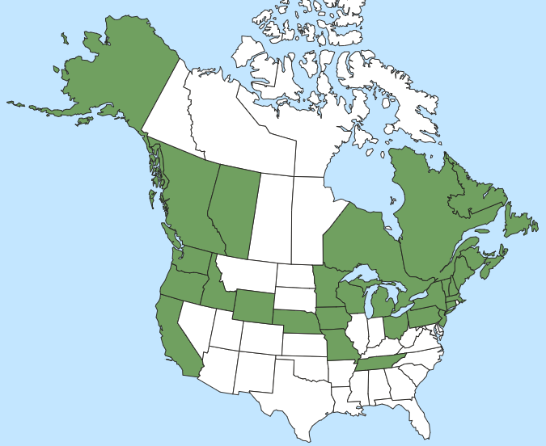

*Range Extent Descriptor⁶: Sparse

֎Rank Calculator Idaho Range Extent: 5,500 sq km (E).

֎Area of Occupancy: Four 4-km² grid cells (C).

*Idaho Counties⁹: Bonner, Boundary, Elmore, Idaho

Idaho Specimens: Put this on a separate spreadsheet if there are numerous specimens
Record source (Herbarium, IFWIS, person) | Date observed/ collected | Observer | County | Location | Abundance, threats, habitat condition
Leiberg 302 | 1891-04-00 | John Leiberg | Bonner | Mouth of Cedar Creek at Lake Pend Oreille | Historic
MacFadden 18693 | 1941-07-05 | Fay MacFadden | Elmore | Atlanta Hot springs
Steele M242 | 1975-08-22 | Robert W. Steele | Idaho | Dixie Road above Deer Creek
Bursik 2469 | 1992-08-26 | Rob Bursik | Bonner | Gamble Lake
Gray 1300 | 1996-09-03 | Gray and Hill | Boundary Creek | Perkins Lake

Literature Records:

Databases/Herbaria consulted (and query date): Consortium of Pacific Northwest Herbaria, Consortium of North American Bryophyte Herbaria

Research Notes:

Abundance:

*֎Number of Occurrences⁸: There are 4 population locations plus 1 historic (1891) location. (A)

֎Population Size: Unknown (U)

֎Number of Occurrences with Good Viability: Viability of the populations has not been evaluated, so between 0 and 4 with good viability. (AC).

Conservation concerns:

֎Threats (include scope, severity and timing, if known): Unknown; threats have not been assessed. Unknown (U)

*֎Overall Threat Rank¹¹: Unknown (U)

֎Intrinsic Vulnerability: (Optional; Used only if Threats unknown. A= highly, B=moderately, C=not intrinsically vulnerable.)

Population trend:

֎Short:

֎Long:
Proposed rank information:

*Date Ranked⁵: Met the North Idaho Rare Plant Working Group on 1/18/2022.

*Proposed Rank: S1S2

*Proposed INPS Status²: Rare

*Comments¹²:

*Recommended actions¹³:

Information Sources:

Consortium of Pacific Northwest Herbaria. (http://www.pnwherbaria.org, December 2020).

Consortium of North American Byrophyte Herbaria. (https://bryophyteportal.org/portal, December 2020).

Flora of North America, Volume 28.

McClune, B. and M. Hutten. 2018. Common Mosses of Western Oregon and Washington. 148pp.

NatureServe Explorer. (http://explorer.natureserve.org, December 2020)

Schofield, W. B. 1992. Some Common Mosses of British Columbia. 394pp.

