Carex limosa Linnaeus – mud sedge
Cyperaceae – sedge family
Account written by Derek Antonelli, December 12, 2021
Recommended S3S4 by Rare Plant Working Group on 2021/12/14

Current Conservation Status:

*NatureServe³: G5, Idaho SNR. Other ranks: OR SNR, WA SNR, BC S5, MT S3S4, NV SNR, UT S3?, WY S3

2009 INPS rank²: Not listed

BLM: Not listed
FS Reg 1: Not listed
FS Reg 4: Not listed
FS Reg 6: Not listed

FWS: Not listed

Taxonomy: Carex limosa Linnaeus, Sp. Pl. 2: 977. 1753.

Synonyms:

Other Subspecies/Varieties: None

Type Locality:

*Taxonomic key(s)⁷: Flora of the Pacific Northwest, Flora of North America, Field Guide to Intermountain Sedges, Field Guide to the Sedge of the Pacific Northwest

Species Description (OPTIONAL): Culms usually aphyllopodic, without dead leaf remains at base, 20–60 cm. Leaf blades 1–2.5 mm wide, margins involute, scabrid. Inflorescences: proximal bracts 2–6 cm, shorter than inflorescences; lateral spikes sometimes androgynous, 6–20 × 4–8 mm, with 8–30 perigynia; terminal spikes 7–35 × 1.5–2.5(–3) mm. Pistillate scales ovate to ovate-circular, 3–5.5 × 2–3.4 mm, wider and as long as or slightly longer than perigynia, apex obtuse to subacute, sometimes mucronate. Staminate scales obovate, 3–4.5 × 1.4–1.6 mm, apex obtuse, sometimes mucronate. Anthers 2–3 mm. Perigynia 2.5–4 × 1.8–2.6 mm, apex rounded; beak 0.1–0.5 mm.

Biology: Life span (perennial); growth form (graminoid); fruiting (summer)

Similar species: Carex magellica ssp. irrgua

Habitat: Sphagnum bogs, wet meadows, shores; Elevation: 0–2000 m

Environmental Specificity¹⁰: Narrow

Cultural and commercial values:

Landownership: Multiple

Distribution:

Global Range: Circumboreal

Range Extent Descriptor: Sparse

Rank Calculator Idaho Range Extent: [F] 93,600 sq km

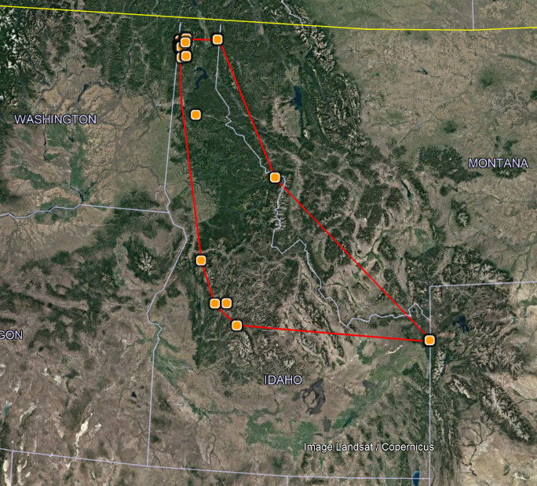

Area of Occupancy: [E] 24 4-sq km grid cells. Twenty-four distinct population locations.

Idaho Counties: Bonner, Boundary, Custer, Fremont, Idaho, Kootenai, Valley

Idaho Specimens: 24 distinct population locations

Idaho Population Locations of Carex limosa
Location | Herbarium Specimen | EO Associate*
Bonner County
Armsrtrong Meadows | X
Bottle Lake | X | X
Caribou Marsh |  | X
Chase Lake | X | X
Dubius Creek |  | X
Hager Lake | X | X
Kalispell Creek | X
Kaniksu Marsh RNA | X | X
Lee Lake | X | X
Mosquito Bay Fen | X
Potholes RNA | X | X
Priest River | H
Upper Priest Lake Shore | X
Boundary County
Jessica's Fen | X
Perkins Lake | X | X
Custer County
Cape Horn | X
Fremont County
Yellowstone National Park | X | X
Idaho County
Lava Butte | X
Packer Meadow | X
Kootenai County
Rose Lake Fen | X
Twin Lakes Fen |  | X
Valley County
Mud Lake | X | X
Tule Lake | X
Warm Lake |  | X
*Listed as an associated species in another species EO record

Literature Records:

Databases/Herbaria consulted (December 2021): USDA PLANTS, BONAP, NatureServe, Flora of North America, and Consortium of Pacific Northwest Herbaria

Research Notes:

Abundance:

Number of Occurrences: [C] 24 distinct population locations

Population Size: [E] Unknown, but probably approaching 10,000

Number of Occurrences with Good Viability: [D] Unknown, but probably at least 13 based on EO status of associated species

Conservation concerns:

Threats: Unknown, but probably similar to threats of Carex magellanica ssp. irrigua (Medium) and Carex chordorrhiza (High to medium) therefore High to medium.

Overall Threat Rank: [BC] High to Medium

Intrinsic Vulnerability:

Population trend:

֎Short:

֎Long:
Proposed rank information:

Date Ranked: Recommended by North Idaho Rare Plant Working Group on 2021/12/14.

*Proposed Rank: S3

*Proposed INPS Status²: Tracking as a rare species not required as this species is co-located with many other rare species. Most of the population locations already have some level of protection.

*Comments¹²:

*Recommended actions¹³: C
¹”Scientific Name” and “Common Name” primarily refer to the scientific and common names used in NatureServe Explorer, respectively. Names not used by NatureServe may be used under some circumstances (i.e., species not yet described, FNA accepted name not updated to NatureServe yet). Synonymous scientific names should be added to the “Synonym” column if applicable. In case when the “Scientific Name” is not the NatureServe name, where applicable, the NatureServe name will be provided under “Synonym” followed by “(NatureServe name)”.

²”2009 INPS rank” is designation from 2009 list, or indicate “Not listed” if the plant is a new addition. If a plant has been ranked at an RPC since 2009, note ranking and date here. INPS status is RARE or Review.

Agency Statuses are available from lists on the Forum under Conservation Rankings/ Forms and Definitions

³”NatureServe Rank” is the NatureServe rank designated in NatureServe Explorer (dark gray, not bolded), which is replaced by updated ranks (black, bolded) as IDNHP and INPS apply the NatureServe Rank Calculator. A “+”follows the G and/or T rank if the species is an Idaho endemic and has the sole rank global and/or trinomial rank authority.

⁵”Date Ranked” is the date in month/year format, followed in parentheses by the NatureServe Rank Calculator version that was used for ranking the species.

⁶”Range Extent” descriptor incorporates thresholds from the NatureServe Rank Calculator and from Walt Fertig’s Rare Plant Ranking System for the Utah Native Plant Society (see table below for land area in each Idaho county). One or more term may apply:
  - Local Endemic = <5,000 km² (ca 2,000 mi² or 2% of Idaho)
  - Subregional Endemic = 5,000 to 20,000 km² (ca 2,000-8,000 mi² or 2-10% of Idaho)
  - Regional Endemic = 20,000 to 200,000 km² (ca 8,000-80,000 mi² or 10-92% of Idaho)
- Local, Subregional, and Regional Endemics are also designated as Core (≥50% of global range) or Edge (<50% of global range) for the part of the species’ distribution in Idaho.
  - Disjunct = Distribution in Idaho is isolated from the main, contiguous portion of a species’ range by a gap of more than 322 km (200 mi).
  - Sparse = Distribution in Idaho is uncommon and scattered, but species otherwise has a wide range (e.g. occurs in multiple states).
  - Peripheral = Distribution in Idaho is at the margin of the species’ main, contiguous portion in an adjacent state or province.
  - Widespread = Species occurs widely across western North America (covering more than 200,000 km²) and across Idaho.

Values used for estimating Range Extent, Area of Occupancy, and Number of Occurrence should at minimum be based on review of IDNHP’s IFWIS Database, Consortium of Pacific Northwest Herbaria, and personal knowledge of documented occurrences. Other on-line herbaria (Intermountain Region Herbarium Network, SEINet, etc.) may also be helpful.

⁷”Key(s)” include taxonomic key(s) species is described in. This includes Vascular Plants of the Pacific Northwest/Flora of the Pacific Northwest (FPNW or FPNW2); Intermountain Flora (IMF); and Flora of North America (FNA). If the name in a key is different than the “Species Name”, the synonymous scientific name used in the key should be added below the Species Name.

⁸”Number of Occurrences” are defined as the number of occurrences >1 km apart, and generally only include those for which there is reasonable certainty that still occur (e.g. excluding historical). If needed, the number of occurrences can be calculated by counting the number of species locations greater than 1 km edge-to-edge.

⁹”Counties” correspond to the Idaho counties the species is known to occur or have occurred. A list of county names, land area, and percent contribution is provided below. Questionable or historical counties should be indicated by having a “?” at the end of the county name.

¹⁰”Environmental specificity” corresponds to the Very Narrow, Narrow, Moderate, and Broad categories from the NatureServe Rank Calculator, and may include some key habitat descriptors in parentheses afterwards. This field is not used in the rank calculator unless there is no information on number of occurrences or area of occupancy.

¹¹”Overall Threat Rank” is the calculated threat level from the NatureServe calculator.

¹²” Comments” may include information needs, basis for species addition/deletion from list, and specific threat information.

^{13”}Recommendation” is the recommendation to federal and state agencies based on consensus and/or new information shared at the RPC, followed after the month and year comment was made (e.g. Oct2011). Recommendations should be specific and tangible enough so they can be reasonably accomplished. If species is deleted or reviewed and not added, it will be maintained in a separate list of “Plants Previously Considered or Listed by INPS”. This list includes information in the table above, plus previous status (if applicable), reason for not being listed or being deleted, and date of determination.

LAND AREA AND PERCENT CONTRIBUTION OF IDAHO’S COUNTIES:
County | Area (mi²) | Area (%) | County | Area (mi²) | Area (%)
Ada | 1060 | 1.21 | Gem | 566 | 0.65
Adams | 1370 | 1.57 | Gooding | 734 | 0.84
Bannock | 1147 | 1.31 | Idaho | 8502 | 9.71
Bear Lake | 1049 | 1.20 | Jefferson | 1106 | 1.26
Benewah | 784 | 0.90 | Jerome | 602 | 0.69
Bingham | 2120 | 2.42 | Kootenai | 1316 | 1.50
Blaine | 2661 | 3.04 | Latah | 1077 | 1.23
Boise | 1907 | 2.18 | Lemhi | 4570 | 5.22
Bonner | 1920 | 2.19 | Lewis | 480 | 0.55
Bonneville | 1901 | 2.17 | Lincoln | 1206 | 1.38
Boundary | 1278 | 1.46 | Madison | 473 | 0.54
Butte | 2234 | 2.55 | Minidoka | 763 | 0.87
Camas | 1079 | 1.23 | Nez Perce | 856 | 0.98
Canyon | 604 | 0.69 | Oneida | 1202 | 1.37
Caribou | 1799 | 2.06 | Owyhee | 7697 | 8.79
Cassia | 2580 | 2.95 | Payette | 410 | 0.47
Clark | 1765 | 2.02 | Power | 1443 | 1.65
Clearwater | 2488 | 2.84 | Shoshone | 2636 | 3.01
Custer | 4937 | 5.64 | Teton | 451 | 0.52
Elmore | 3101 | 3.54 | Twin Falls | 1928 | 2.20
Franklin | 668 | 0.76 | Valley | 3734 | 4.27
Fremont | 1896 | 2.17 | Washington | 1474 | 1.68

