Carex tenera Dewey – quill sedge, slender sedge
Cyperaceae – sedge family
Account written by Derek Antonelli, 2021/10/25
Recommended Rank of S1 assigned by North Idaho Rare Plant Working Group on 2021/11/02

Current Conservation Status:

*NatureServe³: G5, not listed for Idaho. Oregon SNR, Washington SNR, British Columbia S4, Montana S3S4, Wyoming S2

2009 INPS rank²: Not listed.

BLM: Not listed
FS Reg 1: Not listed
FS Reg 4: Not listed
FS Reg 6: Sensitive

FWS: Not listed

Taxonomy: Carex tenera Dewey Amer. J. Sci. Arts 8: 97. 1824. Flora of North America recognizes two varieties, var. tenera and var. echinodes, but PLANTS, CPNWH, and NatureServe do not. Recommend we not use the variety since NatureServe does not use it.

Synonyms: Carex tenera var. tenera

Other Subspecies/Varieties, if applicable: See discussion under Taxonomy.

Type Locality:

*Taxonomic key(s)⁷: Flora of the Pacific Northwest, Flora of North America, Field Guide to Sedges of the Pacific Northwest

Species Description (OPTIONAL): Plants densely cespitose. Culms often nodding, 20–90 cm, vegetative culms inconspicuous with few leaves clustered at apex. Leaves: sheaths abaxially hyaline, adaxially whitish mottled, summits U-shaped, shortly prolonged less than 2.8 mm beyond collar, smooth or sometimes papillose (at 30X); distal ligules 1–2 mm; blades 3–5 per fertile culm, 15–35 cm × 1.3–2.5(–3) mm. Inflorescences often flexible and nodding, open, with elongate spikes, brown, (2–)2.5–5 cm × 7–10 mm; proximal internode (4–)7–17(–20) mm; 2d internode (3–)6–10 mm; proximal bracts scalelike or to 1(–4) cm; rachis usually thin and wiry. Spikes 3–8, distant or loosely aggregated, ovoid to globose, 4–10 × 3.5–6 mm, base tapered or clavate, apex rounded. Pistillate scales white-hyaline or pale brown with green to brown midstripe not reaching scale tip, proximal scales ovate, 2.3–3.3 mm, shorter by 0–1.6 mm and narrower than perigynia, apex obtuse on proximal scales, acute on distal. Perigynia erect to ascending, brown, conspicuously 5–7-veined abaxially, veinless or faintly 3–7-veined adaxially, ovate to broadly ovate, plano-convex, 2.8–4(–4.5) × 1.4–1.9(–2) mm, 0.4–0.5 mm thick, 2–2.3 times as long as wide, margin flat, including wing 0.1–0.5 mm wide, ciliate-serrulate at least distally; beak spreading, appressed or ascending; straw colored to reddish brown at tip, flat, ± ciliate-serrulate, abaxial suture inconspicuous, distance from beak tip to achene 1.3–2.7 mm. Achenes ovate, 1.3–1.7 × 0.85–1.1 mm, 0.5 mm thick. 2n = 52, 54, 56.
Biology: Perennial graminoid.

Similar species: Many species of the Carex section Ovales

Habitat: Marshes, wet meadows, etc.

*֎Environmental Specificity¹⁰:

Cultural and commercial values:

Landownership: Private, USFS, and Avista/IDFG

Distribution:

Global Range:
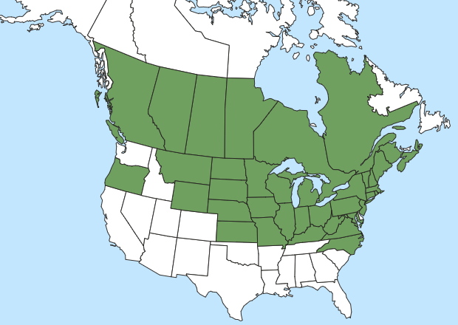

*Range Extent Descriptor⁶: Peripheral

֎Rank Calculator Idaho Range Extent: About 2,298 sq km based on three populations [D]

֎Area of Occupancy: Three 4-km² grid squares [C]

*Idaho Counties⁹: Benewah, Bonner, and Shoshone

Idaho Specimens:
Record source (Herbarium, IFWIS, person) | Date observed/ collected | Observer | County | Location | Abundance, threats, habitat condition
Herbarium specimen | 24 Jun 2012 | Peter Zika 25995 | Bonner | Ellisport Bay, Lake Pend Oreille | Common at site
Herbarium specimen | 15 Jul 2004 | Matt Parks  627 | Shoshone | Moses Butte area | Uncommon at site
Herbarium specimen | 28 Jun 2021 | Derek Antonelli  21-014C | Benewah | Lower St Joe River, Avista/IDFG | Occasional at site

Literature Records:

Databases/Herbaria consulted (and query date): Consortium of Pacific Northwest Herbaria, 2021/10/23

Research Notes

Abundance:

*֎Number of Occurrences⁸: Three known populations [A]

֎Population Size: Probably less than 1000 [C]

֎Number of Occurrences with Good Viability: One to three. Benewah population has good viability. Other population not assessed. [B]

Conservation concerns:

֎Threats (include scope, severity and timing, if known): The threat due to weeds was evaluated as high. Reed canarygrass is a definite threat to the Benewah population. Reed canarygrass was not called out for the Bonner population but is likely there as other weeds are present. Weeds were not called out in the higher altitude meadow for Shoshone. The scope is large with at least two out of three populations exposed to weeds. The severity of the weed impact is serious. The threat due to human intrusion was evaluated as medium. At least one site will have extensive activities to reduce reed canarygrass. While these activities should improve the habitat for Carex tenera long term, there may be a short term impact to the population.

*֎Overall Threat Rank¹¹: The overall threat was evaluated as high. [B]

֎Intrinsic Vulnerability:

Population trend:

֎Short:

֎Long:
Proposed rank information:

*Date Ranked⁵: Reviewed by NIRPWG on 2 Nov 21.

*Proposed Rank: Recommended as S1

*Proposed INPS Status²: Add to rare list.

*Comments¹²:

