*֎Cryptogramma stelleri (S. G. Gmel.) Prantl – fragile rockbrake
Family: Pteridaceae
Account written by Derek Antonelli and Harpo Faust on 1/7/2021 ֎*
Rank of S1 recommended by North Idaho Rare Plant Working Group on 1/12/2021

Current Conservation Status:

*NatureServe³: G5, not listed for Idaho. British Columbia S4S5, Washington S2, Oregon S1, Montana S2S3, Wyoming S1, Utah S1, and Nevada SNR

2009 INPS rank²: Not listed

BLM: Not listed
FS Reg 1: Not listed
FS Reg 4: Not listed
FS Reg 6: Sensitive

FWS: Not listed

Taxonomy: Engler, Bot. Jahrb. Syst. 3: 413. 1882.

Synonyms: Pteris stelleri

Other Subspecies/Varieties, if applicable

Type Locality:

*Taxonomic key(s)⁷: Flora of the Pacific Northwest, Flora of North America

Species Description (OPTIONAL): From FNA: Stems creeping, few branched, slender, 1–1.5 mm diam., succulent, brittle; scales colorless, sparse, transparent-reticulate, ovate, 0.4 × 0.3 mm; stems shriveling in 2d year following emergence of leaves. Leaves scattered along stems, ephemeral (dying by late summer), soon shed; sterile leaves erect, 3–15 cm; fertile leaves erect, 5–20 cm; petioles, costae, and costules glabrous. Petiole dark brown in proximal 1/2 or less, becoming greenish distally, ca. 1 mm wide when dry, only slightly furrowed, glabrous. Blade broadly lanceolate to ovate-lanceolate, all pinnate-pinnatifid to 2-pinnate, herbaceous to membranous, thin; hydathodes superficial, often poorly developed or absent. Segments of sterile leaves ovate-lanceolate to fan-shaped, distal 1/2–1/3 shallowly lobed; segments of fertile leaves horizontal to ascending, often only partially differentiated from sterile leaves, lanceolate to linear, 8–25 × 2–4 mm; margins reflexed, forming continuous false indusia. Sporangia often in discrete sori. 2n = 60.

Biology: Life span (perennial), growth form (fern)

Similar species: Cryptogramma acrostichoides

Habitat: New growth produced in spring, dying by late summer. Sheltered calcareous cliff crevices and rock ledges, typically in coniferous forest or other boreal habitats
Elevation: 0–3000 m

*֎Environmental Specificity¹⁰:

Cultural and commercial values:

Landownership: US Forest Service

Distribution:

Global Range: Circumboreal
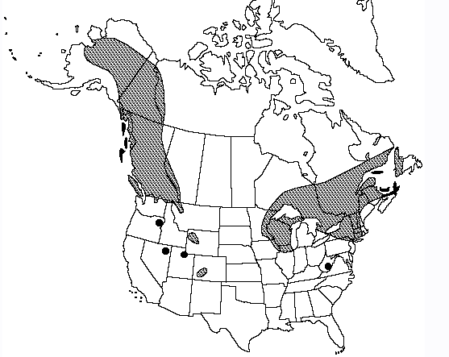

*Range Extent Descriptor⁶: Peripheral

֎Rank Calculator Idaho Range Extent: Two population locations in Idaho—one in Boundary County and one (historic) in the Sawtooth Mountains. Only one population location used for range extent. About 1 square km (A)

֎Area of Occupancy: Two population locations in Idaho—one in Boundary County and one (historic) in the Sawtooth Mountains. Only one population location used for area of occupancy. Two separate collections were made from that single population location. 1 4-km2 grid square (A)

*Idaho Counties⁹: Boundary

Idaho Specimens: Put this on a separate spreadsheet if there are numerous specimens
Record source (Herbarium, IFWIS, person) | Date observed/ collected | Observer | County | Location | Abundance, threats, habitat condition
CPNWH-ID | 7/22/2020 | Faust 3618 | Boundary | Selkirk Mtns | Infrequent
CPNWH-ID | 7/20/2001 | Spribille  11177 | Boundary | Upper Priest Rv Falls | Rare
CPNWH_UBC | Aug 1971 | Pelling s.n. | Sawtooths | Sawtooth Mtns

Literature Records:

Databases/Herbaria consulted (and query date): See Information Sources section below.

Research Notes: Include information here on mis-identified specimens, erroneous reports, location errors, or other relevant information so that others don’t have to chase the same rabbit trails, if applicable

Abundance:

*֎Number of Occurrences⁸: One recent population location and one historic population. One occurrence (A)

֎Population Size: Unknown but small (U)

֎Number of Occurrences with Good Viability: Viability on population not accessed. Zero or one (AB)

Conservation concerns:

֎Threats (include scope, severity and timing, if known): Unknown

*֎Overall Threat Rank¹¹: Unknown (U)

֎Intrinsic Vulnerability: (Optional; Used only if Threats unknown. A= highly, B=moderately, C=not intrinsically vulnerable.)

Population trend:

֎Short:

֎Long:
Proposed rank information:

*Date Ranked⁵: Reviewed by North Idaho Rare Plant Working Group on 1/12/2021

*Proposed Rank: S1

*Proposed INPS Status²: Rare

*Comments¹²:

*Recommended actions¹³:

US Forest Service Region 1 should add species as sensitive species (or equivalent) and manage appropriately

Information Sources:

Consortium of Pacific Northwest Herbaria. (http://www.pnwherbaria.org, Januaruy 2021).

Biota of North America Program, North American Vascular Flora (http://bonap.net/NAPA/Genus/Traditional/County, January 2021)

Flora of North America, Volume 2.

Hitchcock, C.L. and A. Cronquist. 2018. Flora of the Pacific Northwest: An Illustrated Manual, 2nd Edition. Edited by D.E. Giblin, B.S. Legler, P.F. Zika, and R.G. Olmstead. University of Washington Press, Seattle, WA. 936pp.

NatureServe Explorer. (http://explorer.natureserve.org, January 20121)

