*֎Elymus hirsutus J. Presl – northwest ryegrass
Poaceae – grass family
Account written by Harpo Faust and Derek Antonelli, 12/20/2020 ֎*
Recommended S1 by North Idaho Rare Plant Working Group on 1/12/2021

Current Conservation Status:

*NatureServe³: G5. Not listed for Idaho.

Alaska SNR, British Columbia S5, Washington SNR, Oregon S2, California SNR.

2009 INPS rank²: Not listed.

BLM: Not listed.
FS Reg 1: Not listed.
FS Reg 4: Not listed.
FS Reg 6: Not listed.

FWS: Not listed.

Taxonomy:

Synonyms: Elymus borealis

Other Subspecies/Varieties, if applicable: None

Type Locality:

*Taxonomic key(s)⁷: Flora of the Pacific Northwest, 2nd Ed.; Flora of North America, Vol 25; Manual of the Grasses of the United States, 2nd Ed.; Manual of Grasses for North America

Species Description:

Plants cespitose, sometimes shortly rhizomatous. Culms 40-140 cm, usually somewhat decumbent; nodes 4-7, mostly exposed, usually glabrous, occasionally puberulent. Leaves evenly distributed; sheaths usually glabrous and smooth, occasionally scabridulous or retrorsely hairy, sometimes purplish; auricles to 1.5 mm, often absent; ligules to 1 mm; blades 4-12 mm wide, lax, usually deep green, adaxial surfaces usually pilose or villous, occasionally puberulent or scabridulous. Spikes 6-20 cm long, 0.5-2 cm wide, nodding to pendent, with 2 spikelets per node, rarely with 3 at some nodes; internodes 3-10(12) mm long, 0.2-0.7 mm thick at the thinnest sections, usually glabrous, sometimes sparsely hairy. Spikelets 12-20 mm, appressed to divergent, sometimes purplish at higher latitudes, with 2-4(7) florets, lowest florets functional; disarticulation above the glumes and beneath each floret. Glumes equal or subequal, the bases flat, occasionally indurate for 0.5 mm, veins usually evident, glume bodies (4.5)7-10(11) mm long, 0.7-1.5 mm wide, linear-lanceolate, entire, widening or parallel-sided above the base, 3-5-veined, usually scabridulous to scabrous, veins occasionally hirsute beyond midlength, margins hyaline or scarious, awns 1-10 mm, straight; lemmas 7-14 mm, smooth or scabridulous, lateral veins hairy, margins hairy beyond midlength, marginal hairs 0.5-1 mm, longer than those elsewhere, awns (2)8-30 mm, flexuous to moderately outcurving; paleas 6-13 mm, with hairs of varying lengths on the keels and apices, acute, bidentate; anthers 2-3.5 mm. 2n = 28. (from FNA)

Biology: Life span (perennial), growth form (graminoid); anthesis from May to July.

Similar species: Elymus glaucus

Habitat: Elymus hirsutus grows in moist to damp or dry soils in woods, thickets, and grasslands.

*֎Environmental Specificity¹⁰:

Cultural and commercial values:

Landownership: Federal (agency/district), tribal (nation), state, private, other

Distribution:

Global Range: Its range extends along the coastal mountains from the Aleutian Islands to northern Oregon, and inland to eastern British Columbia. Plants in the southern part of the range tend to have villous leaves and more erect spikes with shorter, straighter awns. Map from CPNWH.
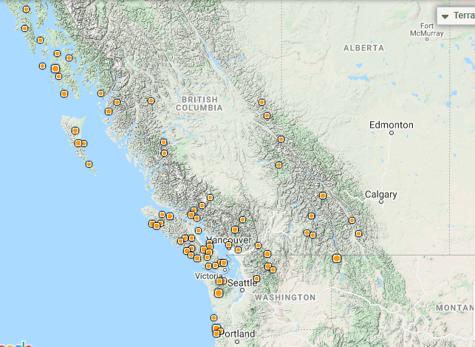

*Range Extent Descriptor⁶: Coastal disjunct in northern Idaho

֎Rank Calculator Idaho Range Extent: 5.76 square km. Calculator category (A).

֎Area of Occupancy: Occupies three 4-sq km grid cells. Calculator category (C).

*Idaho Counties⁹: Boundary

Idaho Specimens:
Record source (Herbarium, IFWIS, person) | Date observed/ collected | Observer | County | Location | Abundance, threats, habitat condition
Faust 3434 | 7/15/2020 | Faust, Legler, Griswold | Boundary | Smith Creek | 1 acre with 500 individuals
Faust 3458 | 7/15/2020 | Faust, Legler, Griswold | Boundary | Smith Creek
Faust 3467 | 7/15/2020 | Faust, Legler, Griswold | Boundary | Smith Creek
Faust 2019-1490 | 7/25/2019 | Faust, Romeo, Pipkin | Boundary | Hidden Lake

Literature Records:

Databases/Herbaria consulted: See Information Sources section below

Research Notes: These collections are first for Idaho

Abundance:

*֎Number of Occurrences⁸: Three. Specimens were collected at four sites but two sites were within 1 km of each other. (A)

֎Population Size: One site noted as having 500 individual within one acre (C).

֎Number of Occurrences with Good Viability: Occurrences were not rated for viability so number with good viability is between zero and three (AB).

Conservation concerns:

֎Threats (include scope, severity and timing, if known): Threats were not determined and therefore are unknown (U).

*֎Overall Threat Rank¹¹: Unknown (U).

֎Intrinsic Vulnerability: (Optional; Used only if Threats unknown. A= highly, B=moderately, C=not intrinsically vulnerable.)

Population trend:

֎Short:

֎Long:

Proposed rank information:

*Date Ranked⁵: NIRPWG recommended rank on 1/12/2021

*Proposed Rank: S1

*Proposed INPS Status²: Rare

*Comments¹²:

*Recommended actions¹³:

US Forest Service Region 1 should add species as sensitive species (or equivalent) and manage appropriately

Information Sources:

Consortium of Pacific Northwest Herbaria. (http://www.pnwherbaria.org, December 2020).

Barkworth, M.E., L.K. Anderton, K.M. Capels, S. Long, and M.B. Piep. 2007. Manual of Grasses for North America. Utah State University Press. 627pp.

Biota of North America Program, North American Vascular Flora (http://bonap.net/NAPA/Genus/Traditional/County, December 2020)

Flora of North America, Volume 24.

Hitchcock, A.S. 1950. Manual of the Grasses of the United States: 2nd Edition. Revised by A. Chase. US Government Printing Office. Dover Publications edition, 1971. 1051pp.

Hitchcock, C.L. and A. Cronquist. 2018. Flora of the Pacific Northwest: An Illustrated Manual, 2nd Edition. Edited by D.E. Giblin, B.S. Legler, P.F. Zika, and R.G. Olmstead. University of Washington Press, Seattle, WA. 936pp.

NatureServe Explorer. (http://explorer.natureserve.org, December 20120)

USDA, NRCS. 2019. The PLANTS Database (http://plants.usda.gov, December 2020).

