Mitella trifida Graham – Pacific mitrewort
Saxifragaceae – Saxifrage family
Derek Antonelli, 2022-02-10
North Idaho Rare Plant Working Group
recommends S2 (2021-02-10)

Current Conservation Status:

*NatureServe³: G5, SNR

2009 INPS rank²: Not listed

BLM: Not listed
FS Reg 1: Not listed
FS Reg 4: Not listed
FS Reg 6: Not listed

FWS: Not listed

Taxonomy: Edinburgh New Philos. J. 7: 185. 1829

Synonyms: Ozomelis trifida – Used in Flora of Pacific Northwest

Other Subspecies/Varieties, if applicable: None

Type Locality:

*Taxonomic key(s)⁷: Flora of North America, Flora of the Pacific Northwest

Species Description (OPTIONAL): Plants not stoloniferous. Flowering stems 12–45 cm. Leaves: petiole 2.5–10 cm, subglabrous or short stipitate-glandular and long stipitate-glandular, longer hairs retrorse, white, tan, or brown; blade cordate, cordate-ovate, or reniform, usually shorter than or sometimes ± as long as wide, 1.2–6 × 2–8 cm, margins shallowly 5- or 7-lobed, crenate, uniformly ciliate, apex of terminal lobe rounded to obtuse, surfaces short stipitate-glandular and sparsely long stipitate-glandular; cauline leaves absent. Inflorescences 1–3, closely 4–20-flowered, 1 flower per node, weakly secund or not secund, 12–45 cm, short stipitate-glandular and, sometimes, sparsely long stipitate-glandular proximally and distally. Pedicels 0.3–1.5 mm, short stipitate-glandular. Flowers: hypanthium campanulate, 1–1.5 × 1.5–2.5(–3) mm; sepals erect or spreading, whitish or purple tinged, oblong to triangular-ovate, 0.8–1.5 × 1–1.3 mm; petals white, sometimes pink or purple tinged, 3-lobed or, sometimes, unlobed, 1–3.5 mm, lobes lanceolate, lateral lobes ascending; stamens 5, opposite sepals; filaments white, 0.1–0.2 mm; anthers 0.1–0.2 × 0.1–0.2 mm; ovary ca. 1/2 inferior; styles divergent, flattened, 0.1–0.2 mm; stigmas unlobed. Seeds dark reddish brown, 0.7–1 mm, pitted. 2n = 14.

Biology: Life span (perennial), growth form (forb); Flowering May–Jul.

Similar species: Mitella stauropetala

Habitat: Deep forest, moist wooded and open slopes
Elevation: 300-2000 m

*֎Environmental Specificity¹⁰:

Cultural and commercial values:

Landownership:

Distribution:
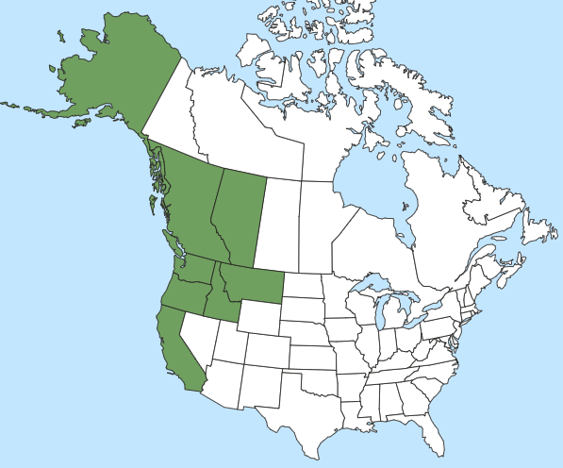

Global Range:

*Range Extent Descriptor⁶: Sparse

֎Rank Calculator Idaho Range Extent: About 18,000 sq km (E).

֎Area of Occupancy: 8 4-km² grid cells (D)

*Idaho Counties⁹: Bonner, Boundary, Caribou, Idaho

Idaho Specimens:
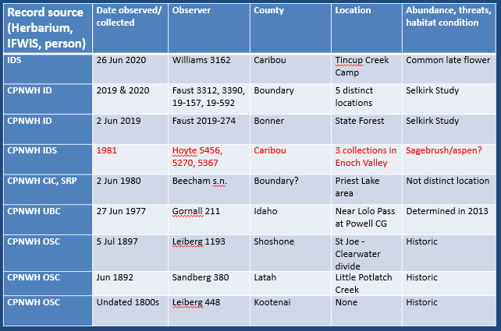

Literature Records:

Databases/Herbaria consulted (and query date): CPNWH (Feb 2022), NatureServe (Feb 2022), PLANTS (Feb 2021), BONAP (Feb 2021)

Research Notes:

Abundance:

*֎Number of Occurrences⁸: 8 locations (D)

֎Population Size: Unknown (U)

֎Number of Occurrences with Good Viability: 0 to 8 (AC)

Conservation concerns:

֎Threats (include scope, severity and timing, if known): Unknown

*֎Overall Threat Rank¹¹: Unknown (U)

֎Intrinsic Vulnerability: (Optional; Used only if Threats unknown. A= highly, B=moderately, C=not intrinsically vulnerable.)

Population trend:

֎Short:

֎Long:
Proposed rank information:

*Date Ranked⁵: NIRPWG recommendation 02-10-2021

*Proposed Rank: S2

*Proposed INPS Status²: Rare

*Comments¹²:

*Recommended actions¹³:

¹”Scientific Name” and “Common Name” primarily refer to the scientific and common names used in NatureServe Explorer, respectively. Names not used by NatureServe may be used under some circumstances (i.e., species not yet described, FNA accepted name not updated to NatureServe yet). Synonymous scientific names should be added to the “Synonym” column if applicable. In case when the “Scientific Name” is not the NatureServe name, where applicable, the NatureServe name will be provided under “Synonym” followed by “(NatureServe name)”.

²”2009 INPS rank” is designation from 2009 list, or indicate “Not listed” if the plant is a new addition. If a plant has been ranked at an RPC since 2009, note ranking and date here. INPS status is RARE or Review.

Agency Statuses are available from lists on the Forum under Conservation Rankings/ Forms and Definitions

³”NatureServe Rank” is the NatureServe rank designated in NatureServe Explorer (dark gray, not bolded), which is replaced by updated ranks (black, bolded) as IDNHP and INPS apply the NatureServe Rank Calculator. A “+”follows the G and/or T rank if the species is an Idaho endemic and has the sole rank global and/or trinomial rank authority.

⁵”Date Ranked” is the date in month/year format, followed in parentheses by the NatureServe Rank Calculator version that was used for ranking the species.

⁶”Range Extent” descriptor incorporates thresholds from the NatureServe Rank Calculator and from Walt Fertig’s Rare Plant Ranking System for the Utah Native Plant Society (see table below for land area in each Idaho county). One or more term may apply:
  - Local Endemic = <5,000 km² (ca 2,000 mi² or 2% of Idaho)
  - Subregional Endemic = 5,000 to 20,000 km² (ca 2,000-8,000 mi² or 2-10% of Idaho)
  - Regional Endemic = 20,000 to 200,000 km² (ca 8,000-80,000 mi² or 10-92% of Idaho)
- Local, Subregional, and Regional Endemics are also designated as Core (≥50% of global range) or Edge (<50% of global range) for the part of the species’ distribution in Idaho.
  - Disjunct = Distribution in Idaho is isolated from the main, contiguous portion of a species’ range by a gap of more than 322 km (200 mi).
  - Sparse = Distribution in Idaho is uncommon and scattered, but species otherwise has a wide range (e.g. occurs in multiple states).
  - Peripheral = Distribution in Idaho is at the margin of the species’ main, contiguous portion in an adjacent state or province.
  - Widespread = Species occurs widely across western North America (covering more than 200,000 km²) and across Idaho.

Values used for estimating Range Extent, Area of Occupancy, and Number of Occurrence should at minimum be based on review of IDNHP’s IFWIS Database, Consortium of Pacific Northwest Herbaria, and personal knowledge of documented occurrences. Other on-line herbaria (Intermountain Region Herbarium Network, SEINet, etc.) may also be helpful.

⁷”Key(s)” include taxonomic key(s) species is described in. This includes Vascular Plants of the Pacific Northwest/Flora of the Pacific Northwest (FPNW or FPNW2); Intermountain Flora (IMF); and Flora of North America (FNA). If the name in a key is different than the “Species Name”, the synonymous scientific name used in the key should be added below the Species Name.

⁸”Number of Occurrences” are defined as the number of occurrences >1 km apart, and generally only include those for which there is reasonable certainty that still occur (e.g. excluding historical). If needed, the number of occurrences can be calculated by counting the number of species locations greater than 1 km edge-to-edge.

⁹”Counties” correspond to the Idaho counties the species is known to occur or have occurred. A list of county names, land area, and percent contribution is provided below. Questionable or historical counties should be indicated by having a “?” at the end of the county name.

¹⁰”Environmental specificity” corresponds to the Very Narrow, Narrow, Moderate, and Broad categories from the NatureServe Rank Calculator, and may include some key habitat descriptors in parentheses afterwards. This field is not used in the rank calculator unless there is no information on number of occurrences or area of occupancy.

¹¹”Overall Threat Rank” is the calculated threat level from the NatureServe calculator.

¹²” Comments” may include information needs, basis for species addition/deletion from list, and specific threat information.

^{13”}Recommendation” is the recommendation to federal and state agencies based on consensus and/or new information shared at the RPC, followed after the month and year comment was made (e.g. Oct2011). Recommendations should be specific and tangible enough so they can be reasonably accomplished. If species is deleted or reviewed and not added, it will be maintained in a separate list of “Plants Previously Considered or Listed by INPS”. This list includes information in the table above, plus previous status (if applicable), reason for not being listed or being deleted, and date of determination.

LAND AREA AND PERCENT CONTRIBUTION OF IDAHO’S COUNTIES:
County | Area (mi²) | Area (%) | County | Area (mi²) | Area (%)
Ada | 1060 | 1.21 | Gem | 566 | 0.65
Adams | 1370 | 1.57 | Gooding | 734 | 0.84
Bannock | 1147 | 1.31 | Idaho | 8502 | 9.71
Bear Lake | 1049 | 1.20 | Jefferson | 1106 | 1.26
Benewah | 784 | 0.90 | Jerome | 602 | 0.69
Bingham | 2120 | 2.42 | Kootenai | 1316 | 1.50
Blaine | 2661 | 3.04 | Latah | 1077 | 1.23
Boise | 1907 | 2.18 | Lemhi | 4570 | 5.22
Bonner | 1920 | 2.19 | Lewis | 480 | 0.55
Bonneville | 1901 | 2.17 | Lincoln | 1206 | 1.38
Boundary | 1278 | 1.46 | Madison | 473 | 0.54
Butte | 2234 | 2.55 | Minidoka | 763 | 0.87
Camas | 1079 | 1.23 | Nez Perce | 856 | 0.98
Canyon | 604 | 0.69 | Oneida | 1202 | 1.37
Caribou | 1799 | 2.06 | Owyhee | 7697 | 8.79
Cassia | 2580 | 2.95 | Payette | 410 | 0.47
Clark | 1765 | 2.02 | Power | 1443 | 1.65
Clearwater | 2488 | 2.84 | Shoshone | 2636 | 3.01
Custer | 4937 | 5.64 | Teton | 451 | 0.52
Elmore | 3101 | 3.54 | Twin Falls | 1928 | 2.20
Franklin | 668 | 0.76 | Valley | 3734 | 4.27
Fremont | 1896 | 2.17 | Washington | 1474 | 1.68

