Monarda fistulosa L. var. menthifolia (Graham) Fernald
Mintleaf bergamot
Lamiaceae – Mint Family
Account written by Derek Antonelli on 1/24/2021
Recommended Rank assigned by Rare Plant Working Group on 2/10/2021

Current Conservation Status:

*NatureServe³: G5T5, Idaho SNR. BC S4, MT SNR, OR SNR, UT S1, WA not listed, WY S4

2009 INPS rank²: Not listed

BLM: Not listed
FS Reg 1: Not listed
FS Reg 4: Not listed
FS Reg 6: Not listed

FWS: Not listed

Taxonomy:

Synonyms: Monarda fistulosa ssp. fistulosa var. menthifolia

Other Subspecies/Varieties, if applicable: None in Idaho

Type Locality:

*Taxonomic key(s)⁷: Flora of the Pacific Northwest

Species Description (OPTIONAL):

Biology: Life span (perennial), growth form (forb); reproduces by seed; flowers in Idaho June and July based on collected specimens

Similar species:

Habitat: Elevation __; Plant communities; substrate

*֎Environmental Specificity¹⁰:

Cultural and commercial values:

Landownership:

Distribution:

Global Range:
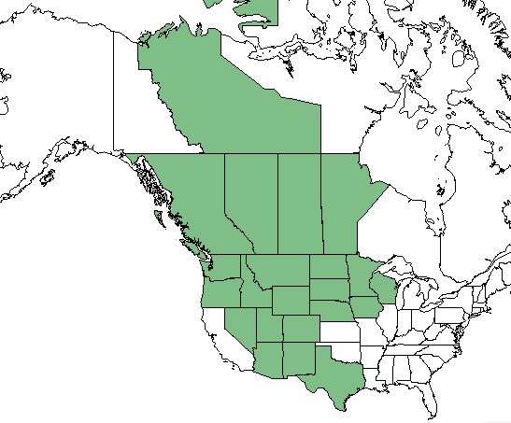

*Range Extent Descriptor⁶: Sparse

֎Rank Calculator Idaho Range Extent: Known from seven locations in Idaho. Six location collections are from 1957 or before. Range extent of all seven sites is about 9,164 sq km. If historic site are excluded then range extent is 1 sq km. (AE)

֎Area of Occupancy: Known from seven locations in Idaho. Six location collections are from 1957 or before. Either seven 4-sq km grid squares or one 4-sq km grid square. (AD)

*Idaho Counties⁹: Boundary, Bonner, Kootenai, Idaho

Idaho Specimens: Put this on a separate spreadsheet if there are numerous specimens
Record source (Herbarium, IFWIS, person) | Date observed/ collected | Observer | County | LAocation | Abundance, threats, habitat condition
CPNWH HPSU | 28 Jul 1992 | Sherry Spenser s.n. | Boundary | Moyie Springs | Difficult to relocate, roadside in mtns
CPNWH ID | 11 Jul 1957 | Kyle E. Laughlin 304 | Idaho | Kamiah | Historic
CPNWH WTU | 4 Jul 1957 | William H. Baker 14992 | Bonner | Blanchard | Historic
CPNWH WTU, ID, SRP | 21 Jul 1955 | William H. Baker 13603 | Bonner | Hope | Historic
CPNWH WS | 24 Jul 1946 | R.F.Daubenmire  46297 | Idaho | Kooskia | Historic
CPNWH IDS | 27 Jul 1941 | Ray J. Davis 3865 | Bonner | Hope | Historic
CPNWH IDS | 25 Jun 1941 | Ray J. Davis 3547 | Idaho | Kooskia | Historic
CPNWH ID, IDS | 7 Jul 1940 | J. H. Christ 11526 | Kootenai | Idlewild Bay,  Lake PO | Historic
CPNWH ID | 28 Jul 1930 | J. H. Christ 827 | Boundary | Bonners Ferry | Historic
CPNWH OSC | Aug 1897 | John B. Leiberg 2916 | Ravalli, MT | Bitterroot River Valley, Grantsdale | NOT IDAHO SPECIMEN

Literature Records:

Databases/Herbaria consulted (and query date): CPNWH 1/24/2021

Research Notes: Christ 11526 is Kootenai not Bonner County. Leiberg 2916 is from Montana not Idaho.

Abundance:

*֎Number of Occurrences⁸: Known from seven locations in Idaho. Six location collections are from 1957 or before. Either seven occurrences or one. (AB)

֎Population Size: Unknown

֎Number of Occurrences with Good Viability: Viability not accessed; between zero and seven. (AC)

Conservation concerns:

֎Threats (include scope, severity and timing, if known): Unknown

*֎Overall Threat Rank¹¹: Unknown

֎Intrinsic Vulnerability: (Optional; Used only if Threats unknown. A= highly, B=moderately, C=not intrinsically vulnerable.)

Population trend:

֎Short:

֎Long:
Proposed rank information:

*Date Ranked⁵: Will meet the NIRPWG on 2/10/2021

*Proposed Rank: S1S2

*Proposed INPS Status²: Rare

*Comments¹²:

Information Sources:

Consortium of Pacific Northwest Herbaria. (http://www.pnwherbaria.org, January 2021).

Biota of North America Program, North American Vascular Flora (http://bonap.net/NAPA/Genus/Traditional/County, January 2021)

Hitchcock, C.L. and A. Cronquist. 2018. Flora of the Pacific Northwest: An Illustrated Manual, 2nd Edition. Edited by D.E. Giblin, B.S. Legler, P.F. Zika, and R.G. Olmstead. University of Washington Press, Seattle, WA. 936pp.

NatureServe Explorer. (http://explorer.natureserve.org, January 2021)

USDA, NRCS. 2019. The PLANTS Database (http://plants.usda.gov, January 2021).

