Montia parvifolia (Moc. Ex DC.) Greene var. batholithica Ertter & C.A.M.Prent.
Batholith springbeauty
Montiaceae (Portulacaceae)
Account written by Carol Prentice & Barbara Ertter, December 2021, 2/7/2022, & 2/17/2022
Recommended Rank assigned by Rare Plant Working Group on Feb 14, 2022 S2

Current Conservation Status:

None (newly described variety)

Montia parvifolia G4G5 SNR, no agency status

Taxonomy: First collection, 1899, first published 2021
Ertter, B., C. Prentice, D.H. Mansfield, J. Kabins, & G.M. Johnson. 2021. A New Variety of Montia parvifolia (Montiaceae) in the High Idaho Batholith of Central Idaho and Adjacent Montana. Journal of the Botanical Research Institute of Texas 15(1):5-22.

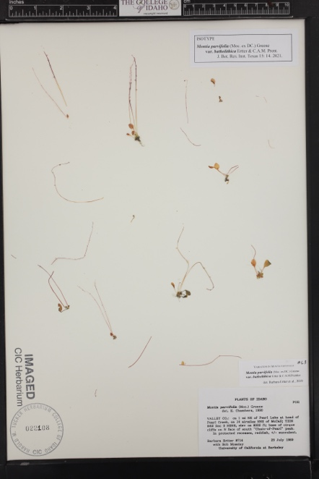 | 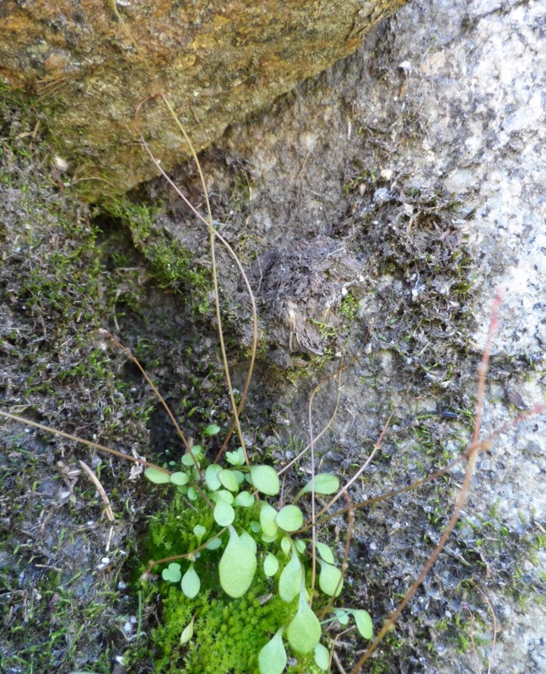 | 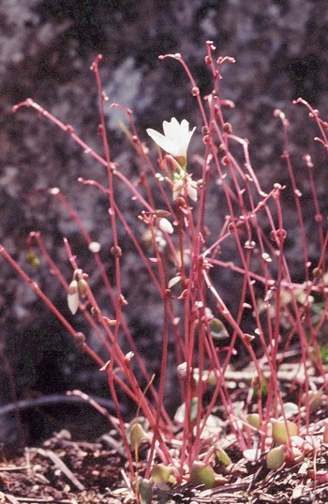
Isotype at CIC Plant with flagelliform stems Flowering plant

Synonyms for Montia parvifolia (Moc. ex DC.) Greene include Claytonia parvifolia Moc. ex DC. and Naiocrene parvifolia (DC.) Rydb. Collections are often mistakenly labeled Claytonia/Montia parviflora, due to nomenclatural (but not morphological or taxonomic) similarities to a member of the miner’s-lettuce species complex; this confusion sometimes carries over to published and other references.

Other Subspecies/Varieties: Typical Montia parvifolia occurs from Alaska to California, occurring inland to Montana and including glaciated portions of northern Idaho, with a widely disjunct collection from the Centennial Mountains of Clark County, ID (Christ 12858, ID). The species barely enters sw Alberta, the only state/province where it has conservation status (critically endangered) Some coastal populations have sometimes been treated as var./ssp. flagelliformis or M. sweetseri. Populations from middle elevations along the Clearwater River drainage, the Seven Devils Mountain, and northeastern Oregon are morphologically intermediate between typical M. parviflora and var. batholithica, and might merit taxonomic status in their own right. Var. batholithica is the only representative of the species known south of the Salmon River in central Idaho (excluding the Seven Devils and Centennial mountains).

Type Locality: U.S.A. Idaho. Valley Co.: ca 1 mi NE of Pearl Lake at head of Pearl Creek, ca 14 air mi NNE of McCall, T20N R4E S9 NENE, 8000 ft, base of cirque cliffs on N face of south “Chain-of-Pearls” peak, 25 Jul 1989, Ertter & Moseley 8714 (holotype: UC 1563790; isotypes:

CIC, ID, NY, OSC).

Species Description:

Differing from other forms of Montia parvifolia in the combination of short stature (to 15 cm), vestigial primary stem, (0–)1–3(–5) basal leaves with broadly obovate-elliptic blades (1–2 times as long as wide), flagelliform stems usually equaling or exceeding flowering stems in number, pedicels no more than 12 mm long, petals no more than 10 mm long, and distribution above 2100 m elevation in the central High Idaho Batholith in Idaho and adjacent Montana

Biology: Cryptically perennial or functionally annual, reproducing primarily by axillary bulblets

Similar species:

Lewisia columbiana, Claytonia sibirica, and C. arenicola have some morphological similarities to M. parvifolia, though the Claytonia species have opposite cauline leaves. See note on nomenclatural similarity to Claytonia/Montia parviflora under Synonyms.

Habitat: Shallow moist soils on north- or east-facing walls of cirques, generally scattered in moist mossy mats on shallow soil over ledges, outcrops, boulders, and talus, or in moist crevices, often near streams or seepage. Elevation 2100 – 2800 m.

Plant associates: Micranthes, Lewisia, Cystopteris, Dodecatheon, Ligusticum, Juncus, and Carex.

Substrate: predominantly granitic, with one record of quartzite.

*֎Environmental Specificity¹⁰: Moderate

Cultural and commercial values: None known

Land ownership: mostly US Forest Service (Payette and Salmon-Challis NFs). Jones 1899 collection site may now be on private (Payette Lake).

Distribution: There are three population clusters: western Salmon River Mountains in west central Idaho, Bighorn Crags in east central Idaho, and mountains in adjacent Montana. The first two population clusters are in the Idaho Batholith south of the main Salmon River. The majority of collections are from eight known localities in the western Salmon River Mountains, in Valley and Idaho counties, Idaho. Four more collections are known from the Bighorn Crags in Lemhi County, Idaho.

Global Range: Idaho and Montana

*Range Extent Descriptor⁶: Subregional endemic (7,640 miles²); Core (with more than 50% of the population in Idaho).

֎Rank Calculator Idaho Range Extent: 1,189 sq miles = Category D

֎Area of Occupancy: Actual number of grid cells is 12, Category D.

*Idaho Counties⁹: Valley, Idaho, Lemhi

Idaho Specimens:

Valley Co., ID
- Payette Lake, 7000 ft., 24 July 1899, M.E. Jones 6197 (RM)
- unnamed peak 1.5 airmi NE of Log Mountain, above W Fork Canton Cr hdwaters & unnamed alpine lake (peak to the SW of lake, highest in cirque bowl), 6 airmi to the S and 25 airmi E of McCall, 8670-8695 ft, UTM 11T 609888.98E 4966189.28N. In granite cliffs and rocky slopes of NE aspect of cirque bowl, locally abundant, collectively forming interwoven mates in rock cracks/thickly growing between rocks, often in thin cracks, reproducing by bulbils, located in leaf axil on prostrate stems. Dominant species: Phyllodoce empetriformis, Abies lasiocarpa, Pinus albicaulis, Pedicularis sp., Luzula sp., 1 Aug 2017, G. M. Johnson 17-230 with S. Mortimer (ID)
- Snowslide Lake ca 10 airmi NE of McCall, N-facing cliffs next to lake, 7300 ft, T19N R4E Sec 14 S of center, uncommon in sheltered crevices, 21 Jul 1988, Ertter, D’Alcamo & Davidson 7780 (UC)
- Snowslide Lake Trail ca 9.5 airmi NE of McCall, T19N R4E Sec 10 SE; also Sec 11 SW, E ½ of et al., 5900-7200 ft, 3 Aug 1999, Handley 2832 (USFS in RM, UC)
- springlet 2/3 up trail to Snowslide Lake from Lick Creek Road, ca 9½ airmiles NE of downtown McCall, 44.9877°N 115.9350°W, ca 2150 m; mossy forest floor with spruce, huckleberry, Ligusticum, Cystopteris, Pedicularis, Potentilla flabellifolia, Erythronium, alder, 14 July 2019, Ertter et al. 23455 (CIC, WTU)
- ca 1 mi NE of Pearl Lake at head of Pearl Creek, ca 14 airmi NNE of McCall, T20N R4E S9 NENE, 8000 ft, base of cirque cliffs on N face of south “Chain-of-Pearls” peak, 25 July 1989, Ertter & Moseley 8714 (CIC, ID, OSC, UC)
- NE-facing cirque slope SW of Pot Lake E of Box Lake, granite ledge traversing slope crossing seeps and streamlets, T19N R4E Sec 4 SWNE, 7800 ft, 27 July 1989, Ertter, Moseley, & Davidson 8788 (UC)
- S side of Deep Lake ca 3 airmi SE of Secesh Summit on Warren Wagon Rd, wet moss on seepage over granite facts & under boulders, 45.161°N 115.933°W, 2266 m, 20 Jul 2014, Ertter & DiNicola 22100 (CIC, UC, WTU)
- Rain Peak, Payette NF on border of McCall & Krassel Ranger Districts, 6 airmi to the E and 12 airmi to the N of McCall [14 mi N on Warren Wagon Rd, then 6 mi E on FS Rd 432, then 2 mi S along FS Tr 109 and 2 mi offtrail to Rain Peak]; collected from summit (8755 ft) while spiraling down to 8255 ft; UTM 11T, 581742E 4991264N; high rocky grant peak with large N aspect cliff & scree field; reproducing by bulbils, located in leaf axils on prostrate stems; locally abundant, collectively forming interwoven mats in rock cracks, 29 July 2016, G. M. Johnson 16-191 with Joy Adams (ID)
- [ID co. line] head of Fisher Creek 17 airmi due N of McCall, T21N R3E Sec 17 SWSW, granite cirque 1-2 mi SW of Saddle, 8200 ft, N-facing wall near snow melt, 20 July 1988, Ertter & D’Alcamo 7750 (CIC, ID, OSC, UC)
Idaho Co., ID
- N-S running ridge top 1 airmi N of Bruin Mt, 1 airmi to the W and 20 airmi N of McCall, 8080-8095 ft, UTM 11T 569380.26E 5004865.15N, collected among granite cliffs and benches along NNE aspect, in minor cirque bowl above unnamed alpine lake, thickly growing in cracks between rocks. Locally abundant, collectively forming interwoven mats in rock cracks. Dominant spp: Vaccinium scoparium, Antennaria media, Phyllodoce empetriformis, Pinus albicaulis, Picea engelmannii, Luzula sp., 17 Aug 2017, G. M. Johnson 17-585 with S. Mortimer (ID)
Lemhi Co., ID
- SE of Terrace Lakes, Bighorn Crags ca 30 airmi W of Salmon, T21S R16E Sec 28 SW, 8800 ft, seepages at edges of N-facing granite cliffs and outcrops, 31 July 1990, Ertter et al. 9455 (CIC, OSC)
- unnamed pond ca 0.6 mi SE of Ship Island Lake, Bighorn Crags, rock ledges, granitic, 8600 ft, 31 July 1990, Mancuso 349 (ID)
- cirque at head of Mirror Lake Drainage, ca ¾ mi S of Mirror Lake, granitic ledges & sandy soil among boulders, 8800 ft, 1 Aug 1990, Atwood 14151 (ID)
- talus & edge above Skyhigh & Turquoise Lakes, quartzite ledges & boulders, 9200-9644 ft, T21N R16E S32, 2 Aug 1990, Atwood 14187 (ID)

Databases/Herbaria consulted (during original research):

NYBG , C. V. Starr Virtual Herbarium, (C. V. Starr Virtual Herbarium - The William & Lynda Steere Herbarium (nybg.org) 2020, 21

Intermountain Region Herbarium Network, (intermountainbiota.org/portal/) 2020, 21

Consortium of Pacific NW Herbaria, 2020 CPNWH Database Search (pnwherbaria.org) 2021

Consortium of California Herbaria (http://ucjeps.berkeley.edu/consortium) 2020, 21

Rocky Mountain Herbarium Database (http://rmh.uwyo.edu/data/search.php) 2020

Research Notes: See original publication.

Abundance:

*֎Number of Occurrences⁸: 12 = B

֎Population Size: unknown

֎Number of Occurrences with Good Viability: 12 = C

Conservation concerns:

֎Threats (include scope, severity and timing, if known): Climate change primarily, also mining and recreation.

*֎Overall Threat Rank¹¹: High-Medium

֎Intrinsic Vulnerability:

Population trend:

֎Short: unknown

֎Long: unknown
Proposed rank information:

*Date Ranked⁵: Initially ranked at Dec 7, 2021 SIRPWG meeting. Re-ranked at 2/14/2022 SIRPWG meeting.

*Proposed Rank: 12/7/21 calculated S3 (with Medium threats); recommended S2S3 due to patchy and highly specific habitat.

2/14/2022 calculated rank S2? with High-Medium threats; now recommend straight S2 rank.

*Proposed INPS Status²: add as Rare

*Comments¹²:

*Recommended actions

Forest Service: add as Sensitive for Payette and Salmon-Challis National Forests.

