Marsh muhly – Muhlenbergia racemosa Britton, Sterns & Poggenb.
Grass family – Poaceae
Account written by Derek Antonelli, March 29, 2016 and updated February 17, 2022

Conservation Status:

*NatureServe³: G5, S2

INPS: S1 (2020 RPC)

BLM: Type 4
FS Reg 1: Not listed
FS Reg 4: Not listed
FS Reg 6: Not listed

FWS: Not listed

Taxonomy:

Synonyms: Agrostis racemosa Michx.

Type Locality:

*Taxonomic key(s)⁷: Flora of Idaho, Flora of Pacific Northwest, Manual of the Grasses of the United States, Manual of Grasses for North America

Species Description (OPTIONAL): From FNA: Plants perennial; rhizomatous, not cespitose. Culms 30-110 cm tall, 1-1.5 mm thick, stiffly erect, much branched above the middle, internodes mostly smooth, polished, glabrous or puberulent immediately below the nodes, elliptic in cross section and strongly keeled. Sheaths scabridulous, slightly keeled; ligules 0.6-1.5(1.7) mm, membranous, truncate, lacerate-ciliolate; blades 2-17 cm long, 2-5 mm wide, flat, usually scabrous or scabridulous, occasionally smooth. Panicles 0.8-16 cm long, 0.3-1.8 cm wide, lobed, dense; branches 0.2-2.5 cm, appressed; pedicels absent or to 1 mm, strigose. Spikelets 3-8 mm. Glumes subequal, 3-8 mm (including the awns), about 1.3-2 times longer than the lemmas, smooth or scabridulous distally, 1-veined, acuminate and awned, awns to 5 mm; lemmas 2.2-3.8 mm, lanceolate, pilose on the calluses, lower 1/2 of the midveins, and margins, hairs to 1.2 mm, apices scabridulous, acuminate, unawned or awned, awns to 1 mm; paleas 2.2-3.8(4.5) mm, lanceolate, intercostal region loosely pilose on the lower 1/2, apices acuminate; anthers 0.4-0.8 mm, yellowish. Caryopses (1.2)1.4-2.3 mm, fusiform, brown. 2n = 40.

Biology: Perennial. Graminoid.

Similar species: Muhlenbergia glomerata

Habitat: grows on rocky slopes, beside irrigation ditches, in seasonally wet meadows, on the margins of cultivated fields, railways and roadsides, in prairies, on sandstone outcrops, on stream banks, and in forest ecotones at elevations of 30-3400 m.

*Environmental Specificity¹⁰: Moderate

Cultural and commercial values:

Landownership:

Distribution:

*Range Extent⁶: No active populations currently known [Z]

Area of Occupancy: No active populations currently known [Z]

*Idaho Counties⁹: Verified or likely specimens found from Bonner and Fremont counties.
PLANTS and BONAP show eight counties—Boundary, Bonner, Fremont, Madison, Teton, Bingham, Bannock, and Caribou. No verified specimens could be found to substantiate any of these counties except Bonner and Fremont. A specimen (Henderson 7706) from Idaho County was originally submitted as M. racemosa but later determined to be M. mexicana.

Idaho Specimens:
Record source (Herbarium, IFWIS, person) | Date observed/ collected | Observer | County | Location | Abundance, threats, habitat condition
OSC, NY | 1897 | Leiberg 2778 | Bonner | South end of Priest Lake | OSC indicates specimen has character of both M. racemosa and M. glomerata
NY | 1900 | E.D, Merrill 36 | Fremont | St Anthony | Annotated during Muhlenbergia study
NY | 1933 | Christ 2469 | Bonner | Sandpoint Substation
NY, ID, IDS | 1983 | Rosentreter 3259 | Camas | Carey | ID and IDS specimens annotated as Stipa
NY, ID, CS, CM | 1989 | Henderson | Idaho | Salmon River | Henderson annotated as M. mexicana

Literature Records: Listed in Flora of Idaho but no geographic reference given. Except from “Vascular Plant Species of Concern in Idaho”, Bulletin Number 34, University of Idaho follows. I spoke to Karl Holte (one of the authors) if he knew about locations of Muhlenbergia racemosa populations, but he had no recollections of any details from the study.

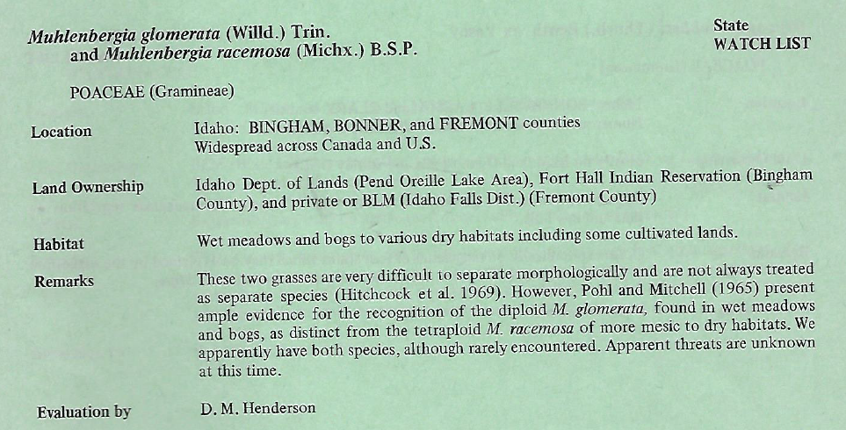

Abundance:

*Number of Occurrences⁸: Three herbaria specimens—most recent is 1933. Only historic populations known [Z]

Population Size: Only historic populations known [Z]

Number of Occurrences with Good Viability: Only historic populations known [A]

Population trend:

Short:

Long:

Conservation concerns:

Threats (include scope, severity and timing, if known): Unknown [U]

Intrinsic Vulnerability:

Proposed rank information:

*Date Ranked⁵: 2/14/2022

*Proposed Rank: SH

*Proposed INPS Status²: Rare

*Overall Threat Rank¹¹: Unknown

*Comments¹²:

*Recommended actions¹³:

¹”Scientific Name” and “Common Name” primarily refer to the scientific and common names used in NatureServe Explorer, respectively. Names not used by NatureServe may be used under some circumstances (i.e., species not yet described, FNA accepted name not updated to NatureServe yet). Synonymous scientific names should be added to the “Synonym” column if applicable. In case when the “Scientific Name” is not the NatureServe name, where applicable, the NatureServe name will be provided under “Synonym” followed by “(NatureServe name)”.

²”INPS Status” is whether INPS has designated the species as “Rare” or “Review”.

³”NatureServe Rank” is the NatureServe rank designated in NatureServe Explorer (dark gray, not bolded), which is replaced by updated ranks (black, bolded) as IDNHP and INPS apply the NatureServe Rank Calculator. A “+”follows the G and/or T rank if the species is an Idaho endemic and has the sole rank global and/or trinomial rank authority.

⁵”Date Ranked” is the date in month/year format, followed in parentheses by the NatureServe Rank Calculator version that was used for ranking the species.

⁶”Range Extent” incorporates thresholds from the NatureServe Rank Calculator and from Walt Fertig’s Rare Plant Ranking System for the Utah Native Plant Society (see table below for land area in each Idaho county):
Local Endemic = <5,000 km² (ca 2,000 mi² or 2% of Idaho)
Subregional Endemic = 5,000 to 20,000 km² (ca 2,000-8,000 mi² or 2-10% of Idaho)
Regional Endemic = 20,000 to 200,000 km² (ca 8,000-80,000 mi² or 10-92% of Idaho)

Local, Subregional, and Regional Endemics are also designated as Core (≥50% of global range) or Edge (<50% of global range) for the part of the species’ distribution in Idaho.

Disjunct = Distribution in Idaho is isolated from the main, contiguous portion of a species’ range by a gap of more than 322 km (200 mi).
Sparse = Distribution in Idaho is uncommon and scattered, but species otherwise has a wide range (e.g. occurs in multiple states).
Peripheral = Distribution in Idaho is at the margin of the species’ main, contiguous portion in an adjacent state or province.
Widespread = Species occurs widely across western North America (covering more than 200,000 km²) and across Idaho.

Values used for estimating Range Extent, Area of Occupancy, and Number of Occurrence should at minimum be based on review of IDNHP’s Plant Conservation Database, Consortium of Pacific Northwest Herbaria, and the Vascular Plant Catalog of the Intermountain Region of Western U.S., and personal knowledge of documented occurrences.

⁷”Key(s)” include taxonomic key(s) species is described in. This includes Vascular Plants of the Pacific Northwest/Flora of the Pacific Northwest (PNW); Intermountain Flora (IMF); and Flora of North America (FNA). If the name in a key is different than the “Species Name”, the synonymous scientific name used in the key should be added below the Species Name.

⁸”Number of Occurrences” are defined as the number of occurrences >1 km apart, and generally only include those for which there is reasonable certainty that still occur (e.g. excluding historical). If needed, the number of occurrences can be calculated by counting the number of species locations greater than 1 km edge-to-edge.

⁹”Counties” correspond to the Idaho counties the species is known to occur or have occurred. A list of county names, land area, and percent contribution is provided below. Questionable or historical counties should be indicated by having a “?” at the end of the county name.

¹⁰”Environmental specificity” corresponds to the Very Narrow, Narrow, Moderate, and Broad categories from the NatureServe Rank Calculator, and may include some key habitat descriptors in parentheses afterwards.

¹¹”Overall Threat Rank” is the calculated threat level from the NatureServe calculator.

¹²” Comments” may include information needs, basis for species addition/deletion from list, and specific threat information.

^{13”}Recommendation” is the recommendation to federal and state agencies based on consensus and/or new information shared at the RPC, followed after the month and year comment was made (e.g. Oct2011). Recommendations should be specific and tangible enough so they can be reasonably accomplished. If species is deleted or reviewed and not added, it should be maintained in a separate list of “Plants Previously Considered or Listed by INPS” (TBD). This list should include information in the table above, plus previous status (if applicable), reason for not being listed or being deleted, and date of determination.

LAND AREA AND PERCENT CONTRIBUTION OF IDAHO’S COUNTIES:
County | Area (mi²) | Area (%) | County | Area (mi²) | Area (%) | County | Area (mi²) | Area (%) | County | Area (mi²) | Area (%)
Ada | 1060 | 1.21 | Butte | 2234 | 2.55 | Gem | 566 | 0.65 | Minidoka | 763 | 0.87
Adams | 1370 | 1.57 | Camas | 1079 | 1.23 | Gooding | 734 | 0.84 | Nez Perce | 856 | 0.98
Bannock | 1147 | 1.31 | Canyon | 604 | 0.69 | Idaho | 8502 | 9.71 | Oneida | 1202 | 1.37
Bear Lake | 1049 | 1.20 | Caribou | 1799 | 2.06 | Jefferson | 1106 | 1.26 | Owyhee | 7697 | 8.79
Benewah | 784 | 0.90 | Cassia | 2580 | 2.95 | Jerome | 602 | 0.69 | Payette | 410 | 0.47
Bingham | 2120 | 2.42 | Clark | 1765 | 2.02 | Kootenai | 1316 | 1.50 | Power | 1443 | 1.65
Blaine | 2661 | 3.04 | Clearwater | 2488 | 2.84 | Latah | 1077 | 1.23 | Shoshone | 2636 | 3.01
Boise | 1907 | 2.18 | Custer | 4937 | 5.64 | Lemhi | 4570 | 5.22 | Teton | 451 | 0.52
Bonner | 1920 | 2.19 | Elmore | 3101 | 3.54 | Lewis | 480 | 0.55 | Twin Falls | 1928 | 2.20
Bonneville | 1901 | 2.17 | Franklin | 668 | 0.76 | Lincoln | 1206 | 1.38 | Valley | 3734 | 4.27
Boundary | 1278 | 1.46 | Fremont | 1896 | 2.17 | Madison | 473 | 0.54 | Washington | 1474 | 1.68

