Phacelia scopulina (A. Nels.) J.T. Howell var scopulina– Prostrate Scorpionweed
Hydrophyllaceae – Waterleaf family
Account written by Carol A. M. Prentice, Oct. 11, 2021& Feb 2022
Recommended Rank S1 assigned by Rare Plant Working Group on Oct 13, 2021

Current Conservation Status:

*NatureServe³: G4TNR, Idaho SNR, Colorado: SNR, Montana: SNR, Nevada: SNR, Oregon: SNR, Utah: SNR, Wyoming: S2 BONAP G4/T4

2009 INPS rank²: Not listed

BLM: none
FS Reg 1: none
FS Reg 4: none
FS Reg 6: none

FWS: none

Taxonomy:

First collection

Marcus E. Jones s.n. Utah, Tooele, Dutch Mt. 1891-06-12

First Publication of Species and synonyms

Emmenanthe foliosa M. E. Jones, Zoe 4:278. 1893. Miltitzia foliosa A. Brand. Pflanzenr.IV. Fam. 251:131. 1913; nor Philippi, 1891. (Jones s.n., Deep Creek Valley above Fuber. Tooele Co. Utah, 8 June 1891; holotype at POM!)=Phacelia lutea var. scopulina.

Emmenanthe scopulina A. Nels. Bull. Torrey Bot. Club 25:380. 1898. (Lectotype: A. Nelson 3056, Green River, Sweetwater County, Wyoming. 31 May 1897. RM! Isolectotypes: US! NY! MO! GH! Syntype: A. Nelson 3026, Green River, Sweetwater County, Wyoming. 30 May 1897. RM! US!)

Miltitzia lutea var. scopulina A. Brand. Pflanzenr IV. Fam. 251:131. 1913. Miltiizia scopulina Rydb. Bull. Torrey, Bot. Club 40:479. 1913. P. scopulina J. T. Howell, Leafl. W. Bot. 4:16. 1944.
P. lutea var. scopulina Cronq. Univ. Wash. Publ. Biol. 17(4):168. 1959. (Nelson 3056, Green River, Sweetwater Co., Wyo., 31 May 1897; lectotype by Howell, at RM!

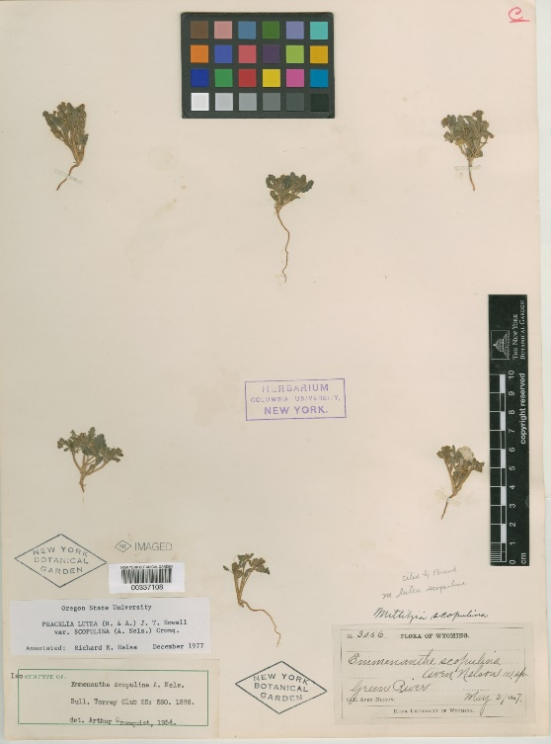
National Herbarium Isolectotype A.Nelson 3056 Green River May 31, 1897
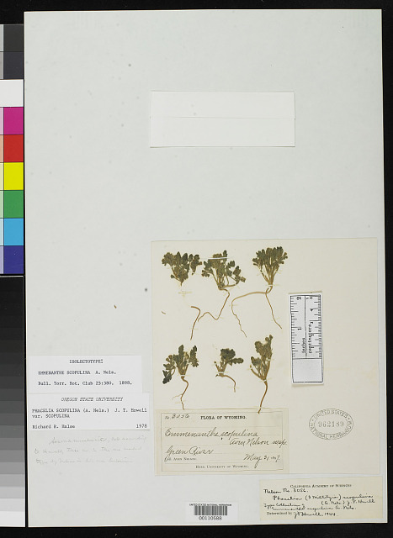

Isosyntype (dup of syntype…part of original description w/out holotype)

Other Subspecies/Varieties, if applicable: None other in Idaho.
Phacelia scopulina var. sulomutica Colorado:S2 Local endemic on clay knolls in Mesa County, Colorado, near DeBeque, and disjunct along the Little Colorado River near Winslow, Arizona (Fig. 9). May to June

*Taxonomic key(s)⁷: Intermountain Flora V.4 p. 176.

Species Description (OPTIONAL): Somewhat mephitic, taprooted annual, freely branched from base.

Biology: Life span - annual, growth form - forb; reproduces by seed; flowers in Idaho May to July.
Fruiting calyx 5-7 ram long; style 1-2 mm long, pubescent half to all of its length; capsule apiculate; n=12.
Alkaline flats and slopes from southwestern Wyoming to central
Nevada, north to southeastern Oregon and adjacent Idaho, disjunct in southwest Montana (Fig. 9). May to July.

Representative specimens: IDAHO. Owyhee Co.: 5 miles S of
Grasmere, Baker 14057 (ID); 2 miles E of Reynolds School, Bratz
B117B -78 (CIC).

Similar species: P. lutea var. l., P. lutea var. calva, P. salina, P. scopulina var. submutica, P. monoensis

Habitat: Elevation 3000 to 5000 feet occupies a great range of edaphic situations, having been collected on alkaline flats, sagebrush flats, gravelly and sandy soils, sterile flats, clay soil, volcanic tuff, and loamy soil. It usually grows in a sagebrush-juniper community associated with such herbs as Lupinus, Phlox, and Bromus tectorum.

*֎Environmental Specificity¹⁰: narrow, white ash

Cultural and commercial values: none known

Landownership: Federal BLM

Distribution:

Global Range: Idaho, Colorado, Montana, Nevada, Oregon, Utah, Wyoming

*Range Extent Descriptor⁶: Peripheral

֎Rank Calculator Idaho Range Extent: Include mapped/estimated actual square km or miles, and the calculator category (A-H, Z, or U). Google Earth polygon 4135 sq miles
Category E

֎Area of Occupancy: Actual number of grid cells and calculator category. 4 grid cells Category C

*Idaho Counties⁹: Owyhee, Cassia, Twin Falls

Idaho Specimens: see below
Locations highlighted in yellow are duplicates.

Literature Records:
Cronquist, A. J., A. H. Holmgren, N. H. Holmgren, J. L. Reveal & P. K. Holmgren. 1984. Vascular Plants of the Intermountain West, U.S.A. 4: 1–573. In A. J. Cronquist, A. H. Holmgren, N. H. Holmgren, J. L. Reveal & P. K. Holmgren (eds.) Intermont. Fl.. Hafner Pub. Co., New York.

Halse, Richard R. “TAXONOMY OF PHACELIA SECT. MILTITZIA (HYDROPHYLLACEAE).” Madroño, vol. 28, no. 3, 1981, pp. 121–132.

Databases/Herbaria consulted (and query date): CPNW Oct. 2021; SEInet Oct 2021; Intermountain Regional Herbaria Network Oct. 2021, CIC Oct. 2021,

Abundance:

*֎Number of Occurrences⁸: 4 = A

֎Population Size: unknown

֎Number of Occurrences with Good Viability: unknown, but unlikely to viable at all four locations given the age of the records and general conditions of habitat. 0-3= AB

Conservation concerns:

֎Threats (include scope, severity and timing, if known): Mining, vehicles (old roadbed), livestock trampling, invasive grasses.

*֎Overall Threat Rank¹¹: High

֎Intrinsic Vulnerability: (Optional; Used only if Threats unknown. A= highly, B=moderately, C=not intrinsically vulnerable.)

Population trend:

֎Short: unknown

֎Long: unknown
Proposed rank information:

*Date Ranked⁵: Preliminary 10/12/2021; by SIRPWG 2/14/2022

*Proposed Rank: Calculated and recommended S1

*Proposed INPS Status²: Add as Rare

*Comments¹²: BLM add as Special Status

*Recommended actions¹³: BLM add as Special Status. Document populations at known sites, locate new populations by searching preferred habitat.

