Pogogyne serpylloides (Torr.) A. Gray – thymeleaf mesamint
Lamiaceae – Mint Family
Account written by Jennifer Miller, 4 December 2020; update 2/17/2022
Recommended Rank assigned by Rare Plant Working Group on 4 December 2020 S1

Current Conservation Status:

NatureServe: G5 [Not ranked in California] [Pogogyne floribunda Jokerst ranked G4S1 in Idaho and Oregon] = G5S1 [combined]

2009 INPS rank: GP3

BLM: None
FS Reg 1: None
FS Reg 4: None
FS Reg 6: None

FWS: None

Taxonomy: First collection = J.J.F. de Jesus Guirado 714, 1860-1862— North America: US and Canada (Region): United States of America: California: San Benito County: San Juan, near Monterey, dry sandy soil; First published = Proceedings of the California Academy of Sciences 4th series, December 18, 1931. The Genus Pogogyne by John Thomas Howell.

Recent or pertinent taxonomic changes = Idaho’s occurrences of Pogogyne floribunda are Pogogyne serpylloides based on—Silveira, M.A. and M.G. Simpson. 2013. Phylogenetic systematics of the mesa mints: Pogogyne (Lamiaceae). Systematic Botany. pg 782-794.

Also, Dr. Alan Prather, Associate Professor of Plant Biology and Director of the Herbarium, Michigan State University, has been working on an FNA treatment that includes Pogogyne. He reviewed specimen image photos for the observation by Heather Swartz and Valerie Geertson at “South of Tenmile Creek, West of Cole Road,” Idaho (EO-1) and determined that the P. floribunda identification more likely fits P. serpylloides.

Synonyms: Pogogyne serpylloides subsp. intermedia J.T. Howell (The Plant List, The Jepson Herbarium). Varieties not recognized by NatureServe.

Other Subspecies/Varieties, if applicable: Include all other subspecies/varieties and list their presence/absence in Idaho (and status/S rank, if any).

Type Locality: Isotype = Pogogyne serpylloides subsp. intermedia—determined by John Thomas Howell: J.J.F. de Jesus Guirado 714, 1860-1862— North America: US and Canada (Region): United States of America: California: San Benito County: San Juan, near Monterey, dry sandy soil

Taxonomic key(s): The Jepson Manual: Vascular Plants of California (page 850). Not in FPNW first or second editions, Flora of Idaho, IMF, and Flora of North America.

Species Description (OPTIONAL): prostrate to decumbent, generally branched INFL: clusters, terminal and auxillary, style sparsely hairy just below stigma, highly aromatic

Biology: Life span─annual, growth form─forb/ herb, reproduces by─seed, flowers in
Idaho—May-June

Similar species: Scientific name of species, but not specific attributes

Habitat: Elevation—EO 1 = 884 m (2900 ft), EO 2 = ~1780 m (5840 ft); Plant communities—vernally wet habitats; substrate

Environmental Specificity: Very narrow (vernally wet habitats)

Cultural and commercial values: Unknown

Landownership: EO 1 = BLM, EO 2 = State

Distribution:

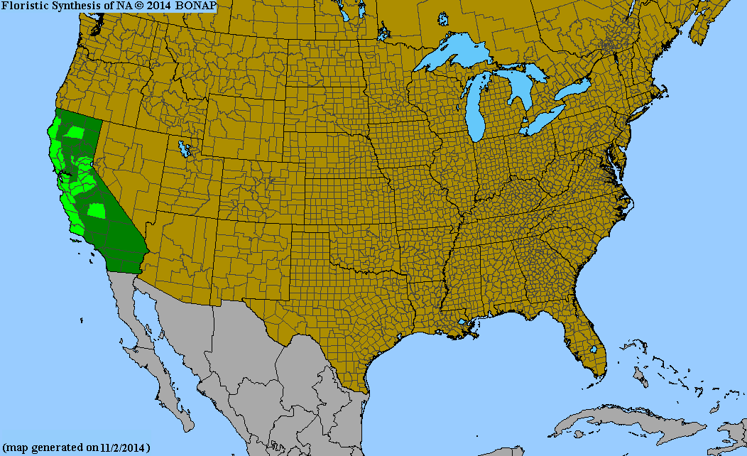
Global Range: California, Oregon, and Idaho
(BONAP map is of Pogogyne floribunda, inset is Pogogyne serpylloides)
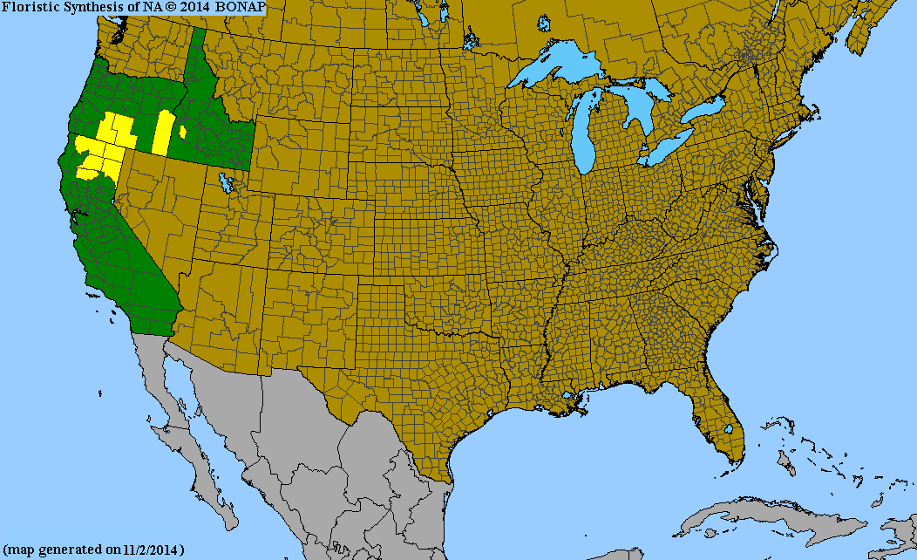
Range Extent Descriptor: southwest Idaho is the northeastern extent of its global range.

Rank Calculator Idaho Range Extent: Include mapped/estimated actual square km or miles, and the calculator category (A-H, Z, or U). A = <100 sq km (<~40 sq mi)

Area of Occupancy: 2 occurrences = B = 2—4 km² grid cells

Idaho Counties: Ada, Owyhee

Idaho Specimens: Put this on a separate spreadsheet if there are numerous specimens

Record source (Herbarium, IFWIS, person) | Date observed/ collected | Observer | County | Location | Abundance, threats, habitat condition | revisit
IFWIS | May 23, 2000 | Heather Swartz & Valerie Geertson | Ada | South of Ten Mile Creek | non-native species | 2020 & 2021-Corbin, Debolt, Kinter, Miller—Failed to Find
IFWIS | June 3, 2009 | Chris Murphy | Owyhee | Highway 51, north of Riddle | <50 plants, livestock trampling | 2021-Corbin, Kinter, Miller—Failed to Find (drought)

Literature Records: Silveira, M.A. and M.G. Simpson. 2013. Phylogenetic systematics of the mesa mints: Pogogyne (Lamiaceae). Systematic Botany. pg 782-794.

Databases/Herbaria consulted (and query date):

IFWIS (24 Nov 2020) = 2

CPNWH (24 Nov 2020) = 1 duplicate (Looked at P. serpylloides & P. floribunda)

IRHN (24 Nov 2020) = 1 duplicate (P. floribunda)

NYBG (24 Nov 2020) = 1 duplicate (P. floribunda)

RMH (24 Nov 2020) = None

Harvard University = None

Research Notes: Include information here on mis-identified specimens, erroneous reports, location errors, or other relevant information so that others don’t have to chase the same rabbit trails, if applicable

Abundance:

Number of Occurrences: 2

Population Size: <50 plants at EO 2 in 2009

Number of Occurrences with Good Viability: None―we looked for EO 1 in 2020 and 2021 and EO 2 in 2021 (2021 was a drought year)

Conservation concerns:

Threats (include scope, severity and timing, if known): Livestock trampling, 2-tracks, Recreational activities, Non-native species, Trash, Drought, herbivory by Mormon crickets

Overall Threat Rank: Very High

Intrinsic Vulnerability: (Optional; Used only if Threats unknown. A= highly, B=moderately, C=not intrinsically vulnerable.)

Population trend:

Short: Unknown

Long: Unknown
Proposed rank information:

Date Ranked: 4 December 2020

Proposed Rank: S1

Proposed INPS Status: Rare

Comments:

Recommended actions: Name change on list, maintain on Idaho Rare Plant List, add to BLM Special Status Plant List, and continue to inventory.

