*֎Porotrichum bigelovii (Sulivant) Kindberg – Bigelow’s porotrichum moss
Neckeraceae
Account written by Derek Antonelli on 2/6/2021 ֎*
S2 Rank recommend by North Idaho Rare Plant Working Group on 2/10/2021

Current Conservation Status:

*NatureServe³: G4, Idaho SNR, Montana S1, British Columbia S4S5, Montana S1, Washington SNR, Oregon SNR

2009 INPS rank²: Not listed

BLM: Not listed
FS Reg 1: Not listed
FS Reg 4: Not listed
FS Reg 6: Not listed

FWS: Not listed

Taxonomy: Canad. Rec. Sci. 6: 18. 1894.

Synonyms: Porothamnium bigelovii, Hypnum bigelovii, Thamnobryum bigelovii, Thamnium bigelovii

Other Subspecies/Varieties, if applicable:

Type Locality:

*Taxonomic key(s)⁷: Flora of North America, Volume 28.

Species Description (OPTIONAL): Plants 2–5 cm. Primary stems complanate-foliate. Primary stem leaves erect-spreading, deltoid, 1–2 mm; margins plane, entire to slightly serrulate; apex acute; costa double, short, or single; basal laminal cells elongate-rhomboidal, 4–10 × 1 µm, smooth; apical cells elongate-rhomboidal, 5–8 µm. Secondary stem leaves 2.5–3 mm; basal laminal cells 8 × 1 µm; medial cells 5–10 × 1 µm; apical cells rhombic to rhomboidal, 3–5 × 2–3 µm. Branch leaves erect to erect-spreading, 1.5 mm; costa to 3/4 leaf length; basal laminal cells 7–10 × 2–3 µm; medial cells 3–7 × 2 µm; apical cells rhombic 3–4 × 2 µm. Perichaetial inner leaves with margins serrate distally, ecostate or costate, distal medial laminal cells fusiform to linear. Seta reddish brown. Capsule erect to horizontal; exostome teeth from broad base tapering toward apex; endostome cilia present.

Biology: Life span (perennial), growth form (moss); note if parasitic; capsules mature Mar–Aug.

Similar species: Scientific name of species, but not specific attributes

Habitat: Soil, rock, logs, under shaded cliffs or shaded boulders by streams, wet rock crevices in forests. Elevation low to moderate elevations (0-600 m)

*֎Environmental Specificity¹⁰:

Cultural and commercial values:

Landownership: Federal, private

Distribution:

Global Range:
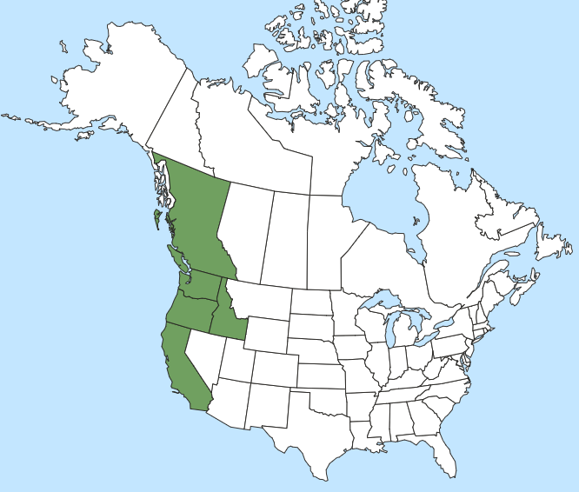

*Range Extent Descriptor⁶: Peripheral

֎Rank Calculator Idaho Range Extent: Approximately 10,350 sq km (E).

֎Area of Occupancy: Seven 4-km² grid squares

*Idaho Counties⁹: Benewah, Bonner, Clearwater, Idaho Kootenai

Idaho Specimens:
Record source (Herbarium, IFWIS, person) | Date observed/ collected | Observer | County | Location | Abundance, threats, habitat condition
NY, UMich, UTenn, WIS, Yale | 1888 thru 1891 | Leiberg | Bonner/  Kootenai | Multiple around Lake Pend Oreille | Historic
USU, UBC | 7/10/1997 | Hanson M510 | Idaho | Salmon River- Mann Creek
WS | 3/20/2000 | Bjork 5147 | Idaho | Lolo Creek Canyon
NY, UBC | 5/31/2000 | Gray 1676 | Clearwater | Dworshak Big Eddy
NY, UBC | 6/6/2000 | Gray 1892 | Clearwater | Dworshak mouth Ove Creek
NY, WTU, UI, MO | 7/27/2000 | Gray 2359, 2360, 2361 | Clearwater | Dworshak Elk Cr Arm
UBC | 7/12/2002 | Bjork 6355 | Benewah | St Maries River
UI | 7/7/2012 | Antonelli s.n. | Bonner | Hager Lake

Literature Records:

Databases/Herbaria consulted (and query date): See below

Research Notes:

Abundance:

*֎Number of Occurrences⁸: Seven population locations plus two historic locations (B)

֎Population Size: Unknown (U)

֎Number of Occurrences with Good Viability: Population viability not assessed so between zero and seven (AC)

Conservation concerns:

֎Threats (include scope, severity and timing, if known): No information on threats

*֎Overall Threat Rank¹¹: Unknown (U)

֎Intrinsic Vulnerability: (Optional; Used only if Threats unknown. A= highly, B=moderately, C=not intrinsically vulnerable.)

Population trend:

֎Short:

֎Long:

Proposed rank information:

*Date Ranked⁵: Reviewed by North Idaho Rare Plant Working Group on 2/10/2021

*Proposed Rank: S2

*Proposed INPS Status²: Rare

*Comments¹²:

*Recommended actions¹³:

Information Sources:

Consortium of Pacific Northwest Herbaria. (http://www.pnwherbaria.org, February 2021).

Consortium of North American Byrophyte Herbaria. (https://bryophyteportal.org/portal, February 2021).

Flora of North America, Volume 28.

McClune, B. and M. Hutten. 2018. Common Mosses of Western Oregon and Washington. 148pp.

NatureServe Explorer. (http://explorer.natureserve.org, February 2021)

