*֎Sphagnum platyphyllum (Lindberg) Warnstorf.
– Flatleaf Peatmoss
Sphagnaceae
Account written by Alma Hanson, 02/03/2021 ֎*
Recommended S1 by North Idaho Rare Plant Working Group on 2/10/2021

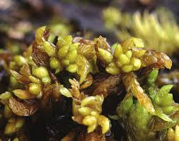
Websites.rbge.org.uk

Current Conservation Status:

*NatureServe³: G5, Idaho S1

British Columbia S3S4, Alberta S2, Colorado S1S2.

INPS rank²: S1

BLM: Not listed
FS Reg 1: Not listed
FS Reg 4: Not listed
FS Reg 6: Not listed

FWS: Not listed

Taxonomy: Flora 67:481

Synonyms: Sphagnum laricinum var.platyphyllim Lindberg, S. contortum var. platyphyllum (Lindberg) Aberg, S. grasslii H.A, Crum, S. subsecundum var. platphyllum (Braithwaite) Cardot

Type Locality:

*Taxonomic key(s)⁷: Flora of North America, Volume 27.

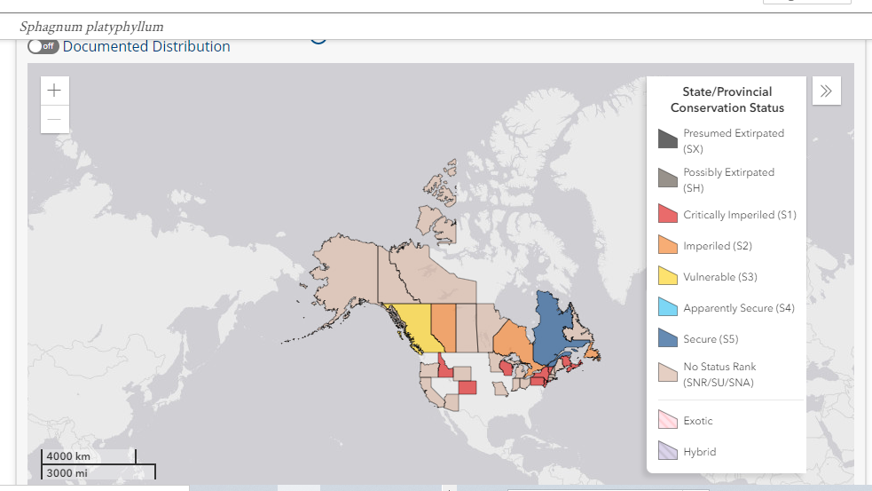

Species Description (OPTIONAL):

Small to medium size peat moss forming yellow-green to brown and black mats or scattered stems. Terminal heads are small and poorly developed with larger terminal buds. Stems are light brown to green with 2-3 layers of thin walled large cortical cells. Stem leaves concave to elliptical. Found in minerotrophic wetlands and open fens.

Biology: Life span (perennial), growth form (moss).

Similar species: Sphagnum contortum.

Habitat: Exposed to submerged in fens, lakeshores, ponds, and other wetlands. From low to high elevations.

Cultural and commercial values:

Landownership: Payette National Forest, Valley County and Boise National Forest, Boise County, Idaho

Distribution: In USA: AK, AZ, CA, CO, CT, ID, IN, MA, ME, MI, MN, MO, NH, NJ, OH, OR, PA, RI, VT, WI, WY. Canada, Europe, Greenland, South America, Eurasia.

Map shows parts of Canada and USA populations; from Consortium of Pacific Northwest Herbaria

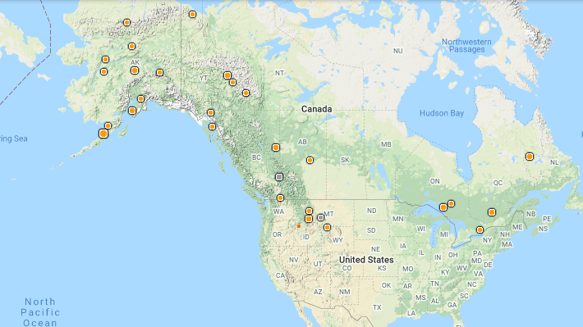

Range Extent: About 760 sq km. (C).
Threat Impact: Medium-Low (CD)
*Idaho Counties⁹: Valley and Boise

Idaho Specimens:
Record source (Herbarium, IFWIS, person) | Date observed/ collected | Obser | County | Location | Abundance, threats, habitat condition
UBC  UBC  BING | 9/17/1999  9/30/2010  07/28/2004 | Schofield Harpel  Hanson, Mancuso  Hahn | Valley  Valley  Boise | Secesh Summit  Buckhorn Meadows  Banner Creek | Small fen along Warren Wagon Rd  Small fen  Fen plot 14

Literature Records:

Databases/Herbaria consulted: See Information Sources section below

Research Notes:

Abundance:

*֎Number of Occurrences⁸: three (A)

֎Area of Occupancy: 3 4-km² grid cells (C)

֎Number of Occurrences with Good Viability: 0 to 3 (AB)

Conservation concerns:

֎Threats (include scope, severity and timing, if known): Road and trail construction along with canopy removal can threaten populations. The primary mechanism for preserving habitat is to maintain the hydrology and water chemistry of the site. Road construction, off road vehicle use and removal of tree canopy immediately adjacent to the fens can destroy local hydrology.

*֎Overall Threat Rank¹¹: Medium-Low (CD).

֎Intrinsic Vulnerability:

Population trend:

֎Short:

֎Long:

֎Calculated Rank:

֎Assigned Rank:
Proposed rank information:

*Date Ranked⁵: NIRPWG recommended rank on 2/10/2021

*Proposed Rank: S1

*Proposed INPS Status²: Rare

*Comments¹²: Current populations are in areas where few management activities occur. However, the population at Secesh Summit is adjacent to a main road. Potential habitat sites remain unsurveyed with the likelihood of finding other populations.

*Recommended actions¹³:

US Forest Service Region 4 should add this species to their sensitive plant list (or equivalent) and manage appropriately.

Information Sources:

Elliott, J.C. and A.K. Pipp. 2018. A Checklist of Montana Mosses (1880-2018). Updated 3 January, 2020. Montana Natural Heritage Program, Helena, Montana. 73pp.

Consortium of North American Bryophyte Herbaria (https://bryophyteportal.org, January 2021).

Consortium of Pacific Northwest Herbaria. (http://www.pnwherbaria.org, January 2021.

Flora of North America, Volume 27.

NatureServe Explorer. (http://explorer.natureserve.org, January 2021)

USDA, NRCS. 2019. The PLANTS Database (http://plants.usda.gov, January 2021).

