**Babs Flat, Idaho Native Plant Society Annual Meeting**

Ty Clayton and Lynn Kinter, 31 May 2025

Overview from Three Island Crossing State Park to parking spot for start of hike:

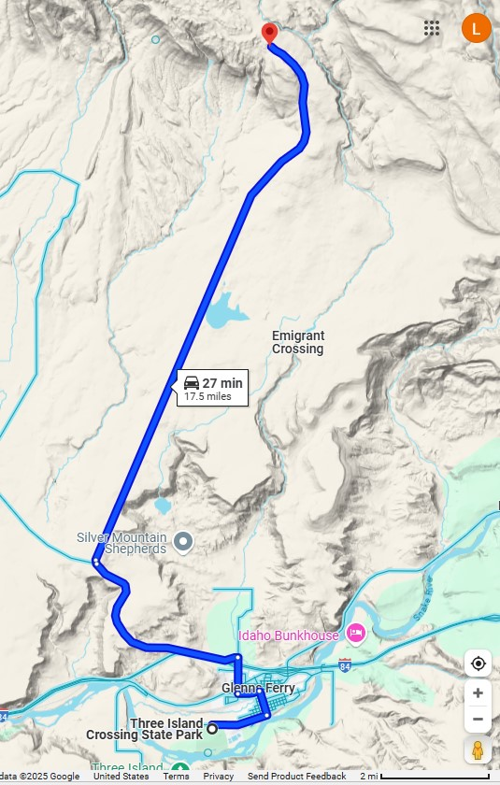

Directions:

On the north side of I-84 (at Exit 120), turn left onto Old Oregon Trail Rd and go west for 3.9 mi.

Veer right onto Bennett Mtn Rd and go north for ~11 mi to parking spot.

(At ~6 mi, you’ll pass King Hill Rd and Blair Trail Reservoir on the right.)

From the parking spot, we will walk east and visit Little Canyon Creek.

Beginning of drive:

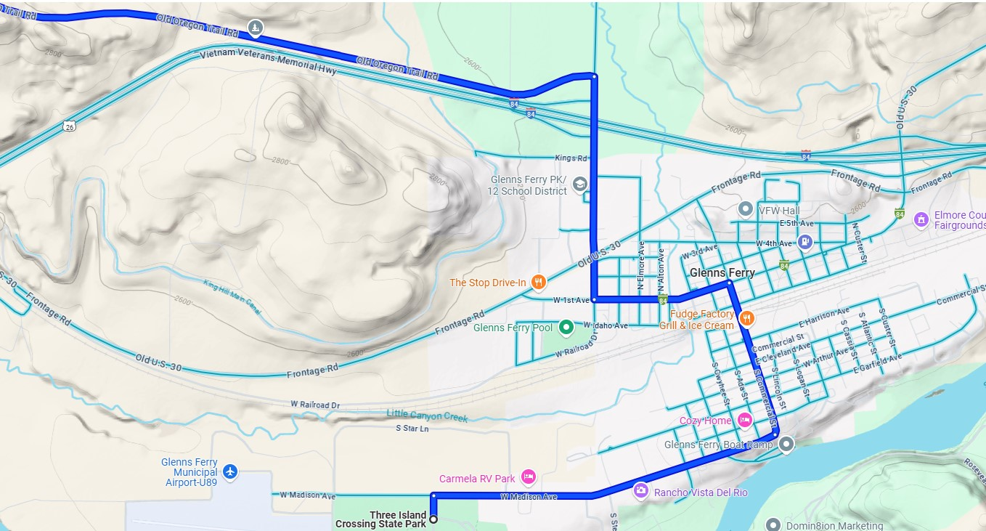

End of drive (to parking spot on Bennett Mountain Road):

