**Directions for Little City of Rocks, north of Gooding, for 3/4 day**

Lynn Kinter and Sandy Smith, 1 Jun 2025

**Glenns Ferry to Little City of Rocks (~45 mi, 1 hr):**

From Glenns Ferry, take I-84 east for ~19 mi to Exit 141 (Bliss).

Go east on Hwy 26 for ~11 mi, to the junction with Hwy 46 at the south edge of Gooding.

Go north on Hwy 46 for 13.0 mi.

At the Little City of Rocks sign, which is 0.1 mi north of milepost 124 (43.10643, -114.67125), turn left onto a dirt road. (Wait here for all of our group to arrive.)

Go northwest on the dirt road for a total of ~1 mi to a parking area and trailhead. Low-clearance vehicles can park ~½ mi before the main parking area and walk the last ½ mi to the trailhead.

**Notes:**

The dirt road into Little City of Rocks crosses private land, which may be closed if the road is muddy due to recent rains. If the road is closed, it’s easy to walk the rest of the way to the trailhead.

At maybe the ½ mi point between Hwy 46 and the trailhead, the dirt road goes near a wet area on the right that has several interesting species. We’ll stop here on the way in.

The trail is clearly defined for ~1.5 mi, which is about the point we typically quit seeing new plants, so we’ll turned around and follow the same trail back out. The trail does continue on and eventually makes a lollipop loop, but comments online say it is not well-defined. The one time I (Lynn) made the loop, our group took a side canyon to the northwest, which was rough, but really neat. On top, we looped south a bit and down another side canyon. Someone in the group had a phone that showed the trail down, otherwise, we would have been completely winging it. If you try the loop, you’ll probably need extra time to scout and figure out the best side canyons to go up and down.

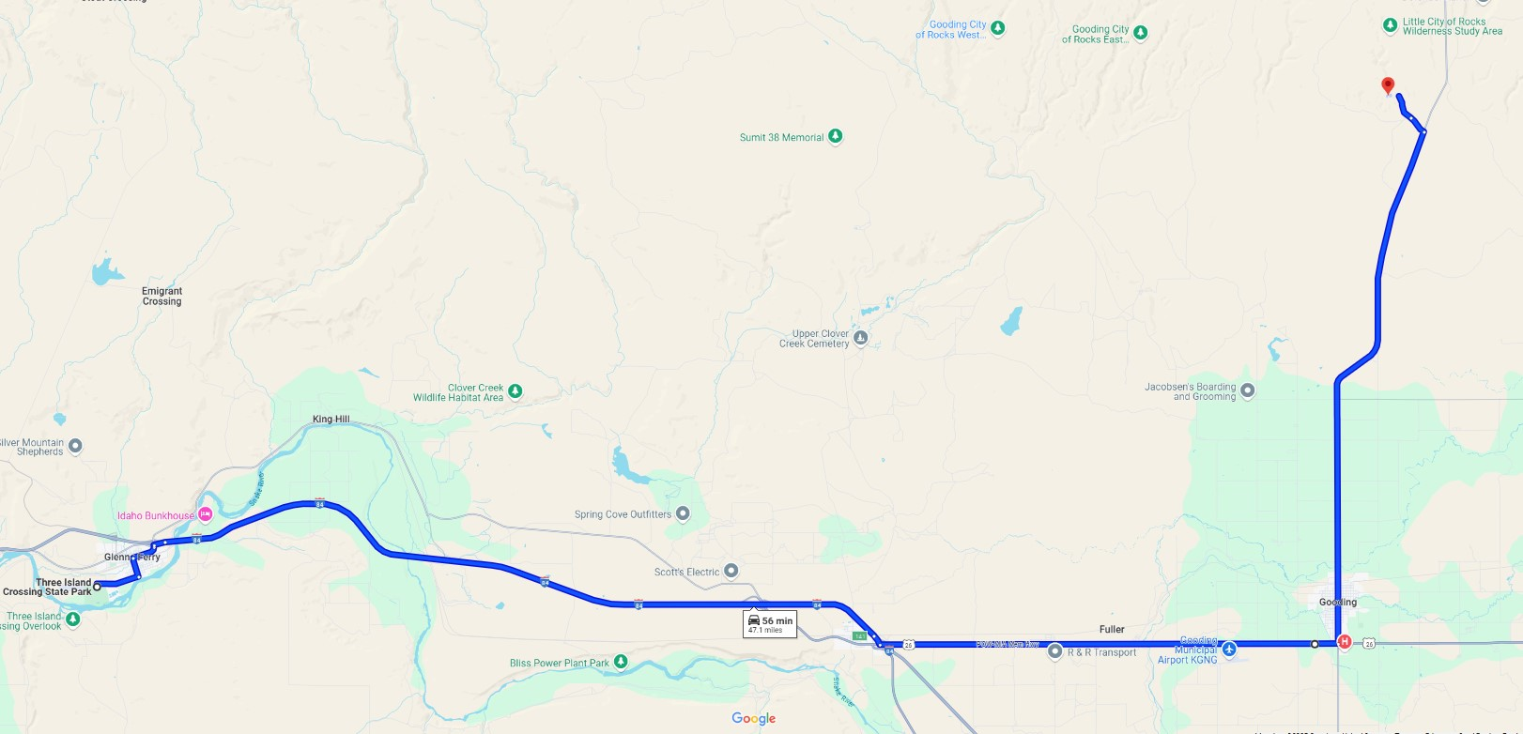

13 mi N of jct on Hwy 46

Jct 26 & 46

Exit 141, Bliss