Mud Flat Rd/Shoofly Oolite Field Trip
The site is known for its unique geologic formations. Ooids (OO-ids), or tiny round pieces of limestone, are called oolite (“egg stone”) when deposited in larger formations. The site’s Shoofly oolite is one of the world’s largest freshwater oolites and provides a unique soil that supports a high density of rare plants, as well as fossils from the prehistoric Lake Idaho.

Directions: Three Island Crossing State Park, 1083 S Three Island Park Dr, Glenns Ferry, ID 83623 to Shoofly Oolite Interpretive Trail Site, Grand View, ID 83624
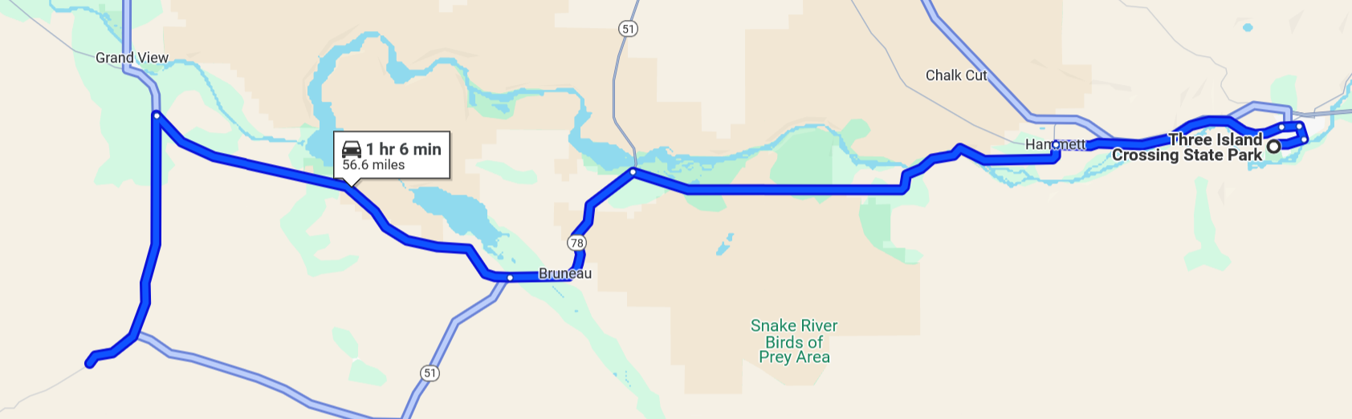
From the State Park
Take W Madison Ave and W 1st Ave to Frontage Rd/Old U.S. 30 W
Turn left onto Frontage Rd/Old U.S. 30 W drive 8.1 mi
Turn left onto ID-78 W drive 15.9 mi
Turn left onto ID-51 S/ID-78 W (signs for Bruneau Elko Nevada) drive 6.7 mi
Slight right onto ID-78 W drive 14.1 mi

Sharp left onto Mud Flat Rd/Shoofly Rd drive 9.6 mi

Parking area will be on the right

Please bring with you:
Plenty of water and a hat as it will be hot and sunscreen
Lunch
Hiking poles and good hiking shoes
Note: There is no shade or bathrooms at this site

